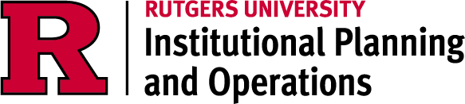

Service Level
Agreement

University Code Office

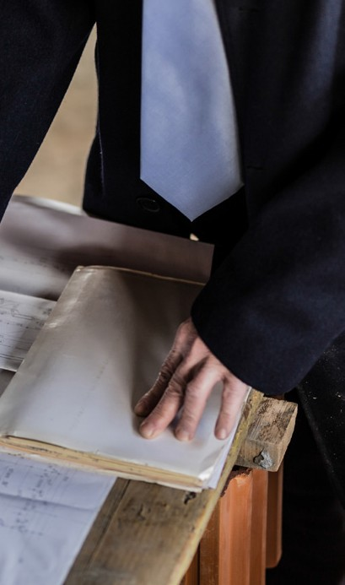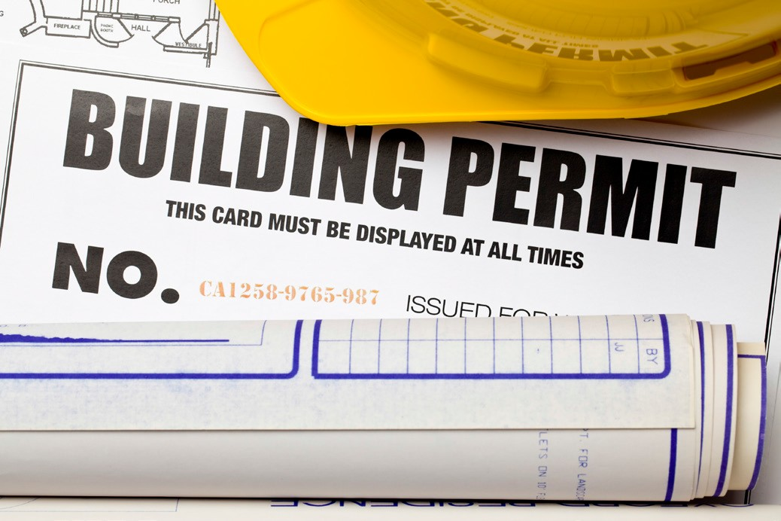

July 1, 2026

TABLE OF CONTENTS

1.0 Service Level Agreement Overview 1
2.0 Description of Services 1
3.0 Service Costs 1
4.0 Service Provider Responsibilities 1
5.0 Problem Management 2
6.0 Key Performance Indicators and Metrics 2
7.0 Periodic Review Process 2
8.0 Out of Scope Services 2

1.0 SERVICE LEVEL AGREEMENT OVERVIEW

This Service Level Agreement (SLA) is intended to identify the basic services, and any agreed upon optional services provided by University Code Office.

This SLA covers the period from July 1, 2026 - June 30, 2027, and will be reviewed and revised at the end of this period.

2.0 DESCRIPTION OF SERVICES

The University Code Office provides plan review, inspections and issues permits and certificates according to the New Jersey Uniform Construction Code.

- SERVICE COSTS

Note: “General and Administrative” RCM Metric uses operating expenses to allocate the cost pool. Exclusions include; direct debt, direct utilities, F&A return, and subcontracts.

In developing the fiscal operating budget (Cost Pool), there are numerous assumptions and sensitivities that are addressed. These include but are not limited to:

    - Changes in aligned employees collective bargaining agreements.
    - Fluctuation in fringe benefit rates.
    - Rise in contract, equipment and supply costs.
    - Mandated regulatory requirements for fire systems and building codes.

- SERVICE PROVIDER RESPONSIBILITIES

    - Plan Review
    - Complete all requested inspections
    - Maintain permit logs
    - Maintain inspection logs
    - Ensure all standards are met or exceeded as set by the New Jersey Uniform Construction Code

Page 1

5.0 PROBLEM MANAGEMENT

All project or site problems are directed to the University Construction Official. The Construction Official will manage through the problem with guidance from the New Jersey Uniform Construction Code.

5.1 SUPPORT & PROBLEM ESCALATION CONTACT LIST

Support Help Line
Name | Role | Phone | Email
William Fox | Executive Administrator | 848-202-2212 | William.fox@rutgers.edu
Support Contacts
Thomas Macor | Plumbing Subcode Official | 848-205-9413 | Thomas.macor@rutgers.edu
Robert Guiliano | Elevator Subcode Official | 908-907-7320 | Robert.guiliano@rutgers.edu
Escalation Contacts
Scott Luthman | Construction Official | 848-202-0333 | Scott.luthman@rutgers.edu

6.0 KEY PERFORMANCE INDICATORS AND METRICS

    - Complete Plan Reviews within 20 business days
    - Complete all inspections within 3 business days

7.0 PERIODIC REVIEW PROCESS

This SLA is a living document and will be reviewed and updated at a minimum of once per fiscal year. Contents of this document may be amended as required, provided mutual agreement is obtained and communicated to all affected parties. University Code Office will incorporate all subsequent revisions and obtain mutual agreements/approvals as required.

8.0 OUT OF SCOPE SERVICES

University Code Office does not charge the university community for any services.

Page 2

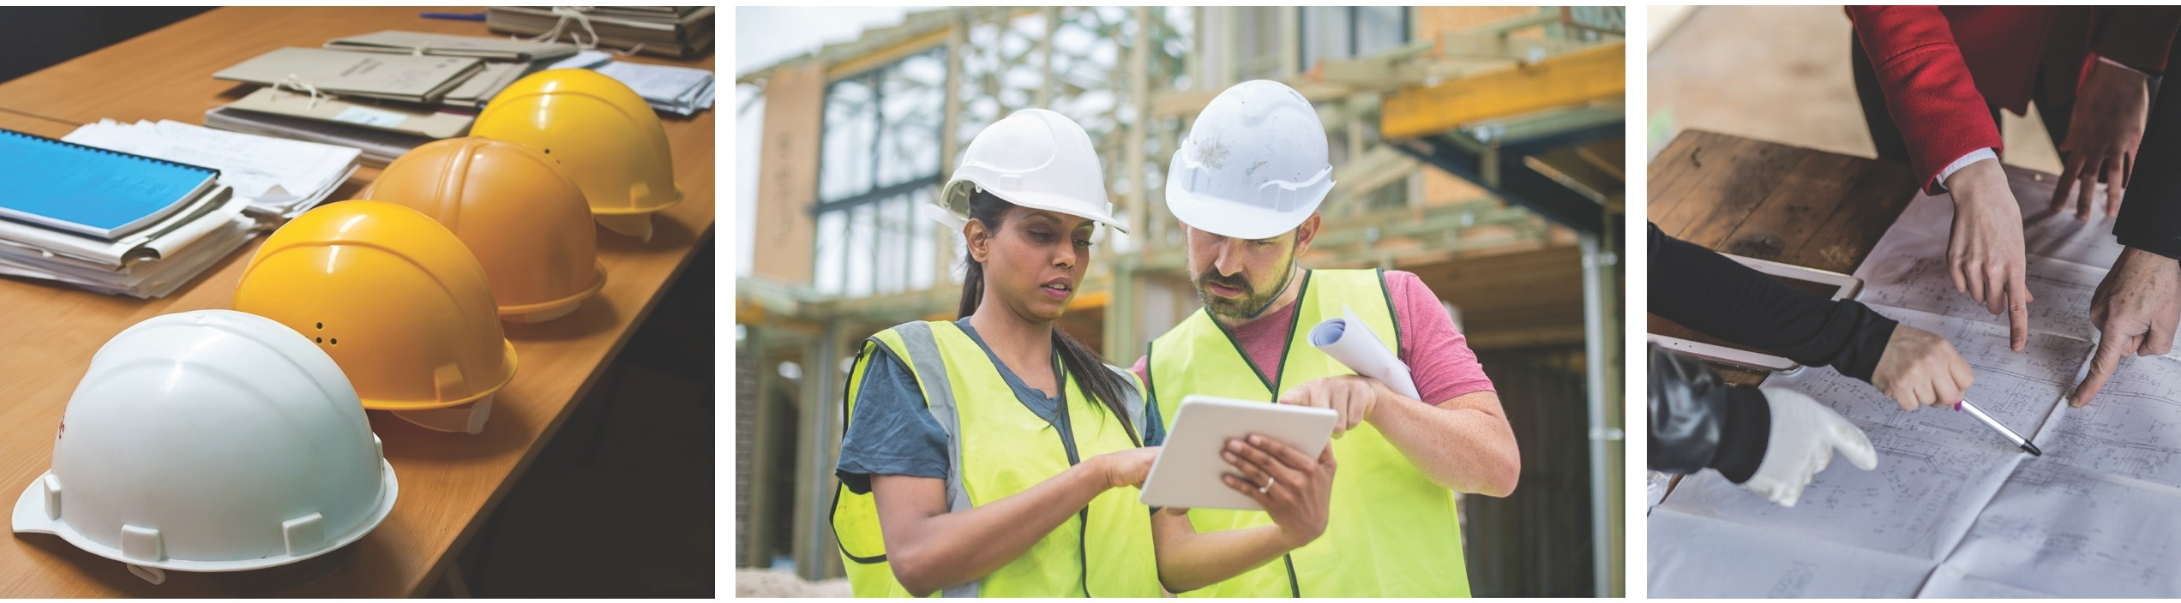

SUPPORTING TODAY, ENVISIONING TOMORROW.

