

Service Level
Agreement

Logistical Services

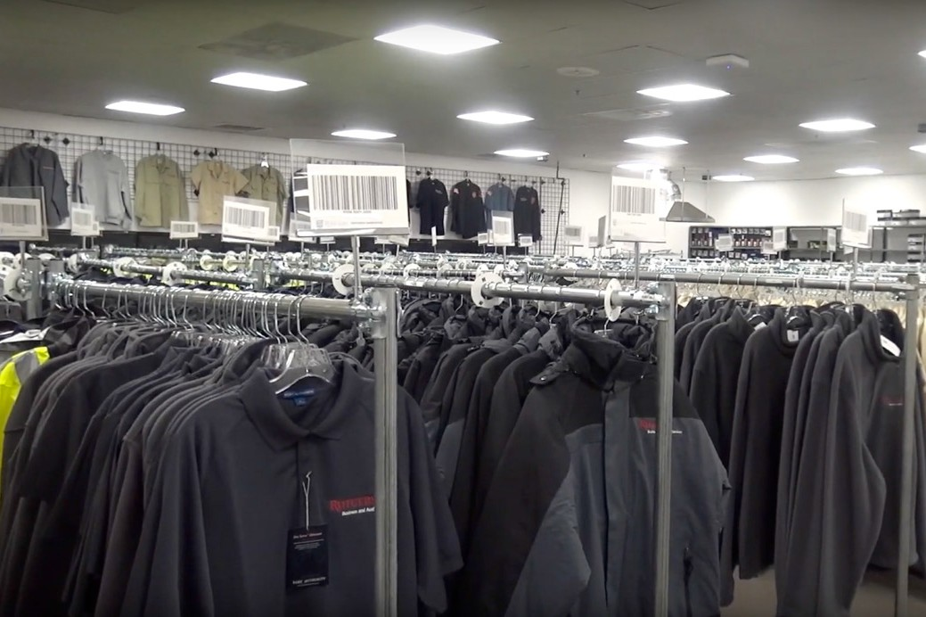

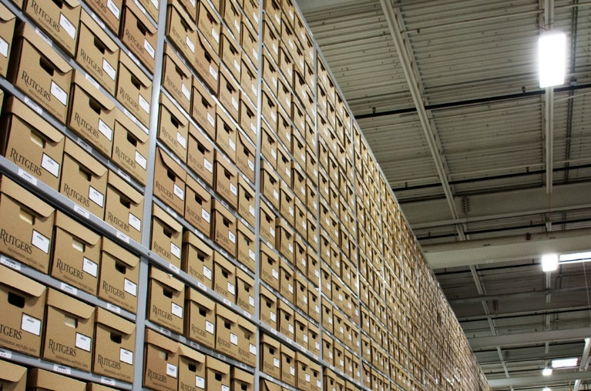
July 1, 2026

TABLE OF CONTENTS

1.0 Service Level Agreement Overview 1
2.0 Description of Services 1
3.0 Service Costs 1
4.0 Service Provider Responsibilities 2
5.0 Problem Management 2
6.0 Key Performance Indicators and Metrics 4
7.0 Periodic Review Process 4
8.0 Out of Scope Services 4

- SERVICE LEVEL AGREEMENT OVERVIEW

This Service Level Agreement (SLA) is intended to identify the basic services, and any agreed upon optional services provided by Logistical Services. Logistical Services is comprised of:

    - Warehouse Operations
    - Shipping and Receiving
    - Surplus Services
    - Uniform
    - Supply and Material Management
    - Signage and Graphic Services
    - Record Retention
    - Shredding Services
    - Fleet Management

This SLA covers the period from July 1, 2026 - June 30, 2027, and will be reviewed and revised at the end of this period.

2.0 DESCRIPTION OF SERVICES

Logistical Services provides the university with moving services and furniture installation. Oversees surplus operations, responsible for pickup and disposal of all university assets which are no longer in use, and also offers surplus items for sale. Logistical Services is responsible for University Warehousing operations, which includes receiving incoming packages for faculty and staff, ordering, inventorying, and delivering supplies for various departments within the university. Fleet Services provides preventive maintenance, repairs, and life cycle planning for university vehicles. Signage and Graphic Services provides vehicle decal branding packages, special event signage, interior signage, plaques, monument signage, custom signage and lettering, poster prints, banners and event parking signage. We also manage the university’s Record Retention facility, shedding service, and E-waste.

3.0 SERVICE COSTS

Note: “General and Administrative” RCM Metric uses operating expenses to allocate the cost pool. Exclusions include: direct debt, direct utilities, F&A return, and subcontracts.

In developing the fiscal operating budget (Cost Pool), there are numerous assumptions and sensitivities that are addressed. These include but are not limited to:

    - Changes in aligned employees collective bargaining agreements.
    - Fluctuation in fringe benefit rates.
    - Rise in contract, equipment and supply costs.

4.0 SERVICE PROVIDER RESPONSIBILITIES

Surplus Operations is responsible for pickup and disposal of university assets which are no longer in use. The Surplus Property Policy defines who is responsible for surplus assets and how to handle the disposal, sale, and transfer of these assets.

Surplus Operations offers surplus items for sale such as used office furniture, computer equipment, electronics, lab equipment, vehicles etc. To see all available items, visit our virtual store http://www.govdeals.com/rutgers and check back often as our inventory changes constantly

The warehouse provides University Facilities and the university community with over 3,500 inventoried maintenance, custodial, electrical, plumbing, hardware, safety, locksmith, painting supplies, and uniforms as well as additional categories. Warehouse Operation have worked with the RU MarketPlace team to create a process to support ordering using the requisitioning process in RU MarketPlace. The hosted catalog is loaded and maintained in RU MarketPlace which when ordered from will trigger Internal Transfer Orders from the Warehouse while still maintaining the approval controls. The Warehouse team will release/pick and deliver (delivery under special circumstances) to fulfill these orders.

The Records Management department provides information to campus departments regarding the proper procedures for retaining and discarding university records. The program assists departments with developing a Records Retention and Disposal Schedule, which is in compliance with federal and state regulations. Records Management assists departments with these decisions and provides effective solutions for the proper retention of university records, special collections and university archives. We strive to achieve economy and efficiency in the creation, maintenance, and disposal of public records.

5.0 PROBLEM MANAGEMENT

Logistical Services operates collaboratively within our group, as well as with colleagues from other internal IP&O departments and outside of IP&O. Should problems arise, the contacts listed on the next page are equipped to manage the issues. Should problems be unresolved, their resolution will be escalated to the Assistant Vice President.

5.1 Support & Problem Escalation Contact List

Support Help Line
Name | Role | Phone | Email
Matthew Dekok | Assistant Director Warehouse Supplies | 848 445-6636 | matt.dekok@rutgers.edu
James Kocha | Assistant Manager Warehouse Supplies | 848-445-2487 | james.kocha@rutgers.edu
James O Brien | Supervisor Material Services Moving Services | 848-445-0797 | jim.obrien@rutgers.edu
Michael McDede | Manager Surplus Services | 848-445-5315 | michael.mcdede@rutgers.edu
Records Management | Administrative | 848-445-8175 | Records.management@ipo.rutgers.edu
Support Contacts
Stephen Dalina | Director  Records Retention | 848-445-8175 | Stephen.dalina@rutgers.edu
David Haines | Director  All Other Services | 848-445-6760 | David.haines@rutgers.edu
Escalation Contacts
William O’Brien | Assistant Vice President Business Service | 848-445-5111 | obrienw@rutgers.edu

- KEY PERFORMANCE INDICATORS AND METRICS

    - Operating expense ratio
    - Picking, packing and delivery process time
    - Uptime of equipment and systems
    - Tracking preventive maintenance schedule
    - Customer satisfaction surveys
7.0 PERIODIC REVIEW PROCESS

This SLA is a living document and will be reviewed and updated at a minimum of once per fiscal year. Contents of this document may be amended as required, provided mutual agreement is obtained and communicated to all affected parties. Logistical Services will incorporate all subsequent revisions and obtain mutual agreements/approvals as required.

- OUT OF SCOPE SERVICES

Out of scope services we be billable based on labor hourly rates plus material or on an agreed to fees. The labor rate will be established each year and subject to change caused by collective bargaining settlements and fringe benefit increases. The service unit will provide an estimate of costs to the requesting unit and the requesting unit will issue an internal purchase order or transfer funds based on the estimate prior to the service unit commencing the work. A final invoice will be issued at the end of the work. Service examples include:

    - All engagements with the Material Services Department
    - Fuel
    - Fleet Services
    - Signage and Graphics Services
    - EZ Pass
    - Records Storage Fees
    - Records Services Fees
    - Destruction/Shredding
    - Shredding Services
    - Scanning/Imaging Projects
    - Storage
    - Special Project Services

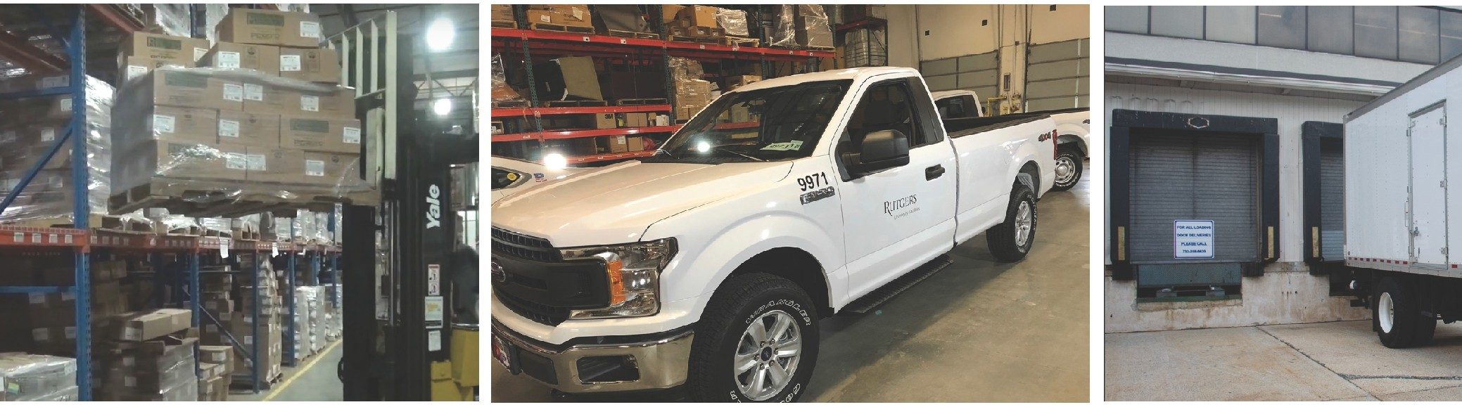

SUPPORTING TODAY, ENVISIONING TOMORROW.

