

Service Level
Agreement

Mail Services

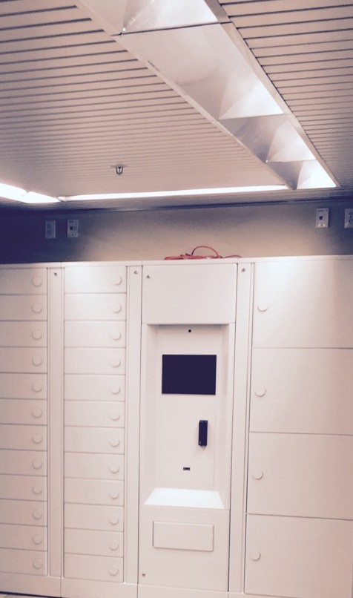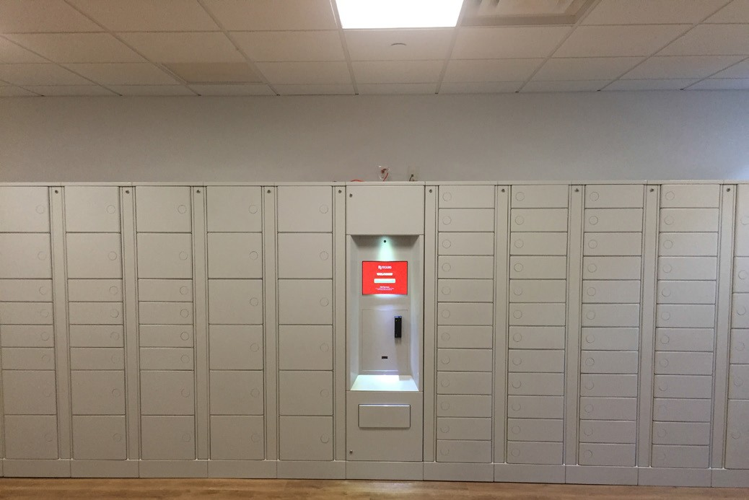

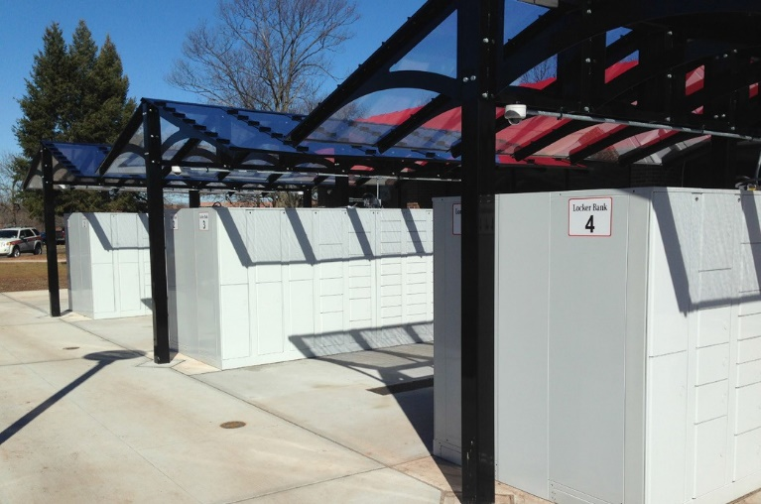
July 1, 2026

TABLE OF CONTENTS

1.0 Service Level Agreement Overview 1
2.0 Description of Services 1
3.0 Service Costs 1
4.0 Service Provider Responsibilities 1
5.0 Problem Management 2
6.0 Key Performance Indicators and Metrics 2
7.0 Periodic Review Process 3
8.0 Out of Scope Services 3

1.0 SERVICE LEVEL AGREEMENT OVERVIEW

This Service Level Agreement (SLA) is intended to identify the basic services, and any agreed upon optional services provided by University Mail, a unit within Business Services.

This SLA covers the period from July 1, 2026 - June 30, 2027, and will be reviewed and revised at the end of this period.

2.0 DESCRIPTION OF SERVICES

Receives, sorts, and delivers U.S. Postal Mail and packages to on campus university departments Monday through Friday on a two day per week schedule during University business hours for the Newark, Rutgers Health and New Brunswick.

Receives, sorts, and delivers all incoming student mail and packages during business hours on the Newark, Rutgers Health and New Brunswick.
- SERVICE COSTS

Note: “General and Administrative” RCM Metric uses operating expenses to allocate the cost pool. Exclusions include: direct debt, direct utilities, F&A return, and subcontracts.

In developing the fiscal operating budget (Cost Pool), there are numerous assumptions and sensitivities that are addressed. These include but are not limited to:

    - Changes in aligned employees collective bargaining agreements.
    - Fluctuation in fringe benefit rates.
    - Rise in contract, equipment and supply costs.

- SERVICE PROVIDER RESPONSIBILITIES

Mail Services strives to provide mailing and shipping services to the campus at a maximum level of efficiency and accountability while meeting the needs and expectations of customers.
The unit offers a wide range of services including bulk mail, intercampus mail, incoming and outgoing mail, courier services, and most services offered by the United States Postal Service including certified and express mail. We will ensure:

    - Timely delivery/pick up of mail for student and staff
    - Assistance with mail inquires and projects
    - Package tracking for students and staff
    - Outgoing student mail and packages
    - Consult on USPS mail design
    - Liaise with USPS post masters
    - Customer Service windows for students located in student post offices

5.0 PROBLEM MANAGEMENT

Problems/Issues are received via email, phone, or in person. These problems/issues are addressed by customer service representatives, supervisors or managers. All inquiries are addressed and handled within 24 hours of the initial request.

5.1 SUPPORT & PROBLEM ESCALATION CONTACT LIST

Support Help Line
Name | Role | Phone | Email
Email System New Brunswick District | Customer Service | N/A | mailquestions@ipo.rutgers.edu
Email System Newark District | Customer Service | N/A | mailquestionsnewark@ipo.rutgers.edu
Support Contacts
Lavone Broxton | Manager (New Brunswick Staff) | 848-932-4261 | Lavone.broxton@rutgers.edu
David Ericksen | Manager (New Brunswick Students) | 848-932-4271 | David.ericksen@rutgers.edu
Sam Bandy | Manager (Newark) | 973-972-4060 | Samuel.bandy@rutgers.edu
Escalation Contacts
Austin Clark | Director Mail Service | 848-932-4267 | austin.d.clark@rutgers.edu
William O’Brien | AVP Business Service | 848-445-5111 | obrienw@rutgers.edu

- KEY PERFORMANCE INDICATORS AND METRICS

    - Plant utilization
    - Overtime value
    - Minimizing cost variances
    - Student, Faculty and Staff satisfaction surveys

7.0 PERIODIC REVIEW PROCESS

This SLA is a living document and will be reviewed and updated at a minimum of once per fiscal year. Contents of this document may be amended as required, provided mutual agreement is obtained and communicated to all affected parties. University Mail will incorporate all subsequent revisions and obtain mutual agreements/approvals as required.

- OUT OF SCOPE SERVICES

    - Out Going Postage Mail Metering
    - Intra Campus Courier Service
    - University Departmental Bulk Mail Pick Up
    - Bulk Mail preparation and delivery to USPS distribution center
    - University Departmental Address List creation and editing
    - Use of Business Reply Mail permit
    - Business Reply Mail preparation and delivery to USPS distribution center
    - Special Pick Up and Deliveries Services on New Brunswick and Newark districts
    - Special Off Campus Delivery Services

Billable rates will be based on labor hourly rates plus material. The service unit will provide an estimate of costs to the requesting unit and the requesting unit will issue an internal purchase order or transfer funds based on the estimate prior to the service unit commencing the work. A final invoice will be issued at the end of the work.

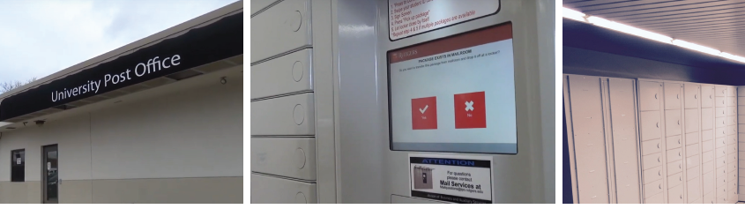

SUPPORTING TODAY, ENVISIONING TOMORROW.

