

Service Level
Agreement

Strategic Services

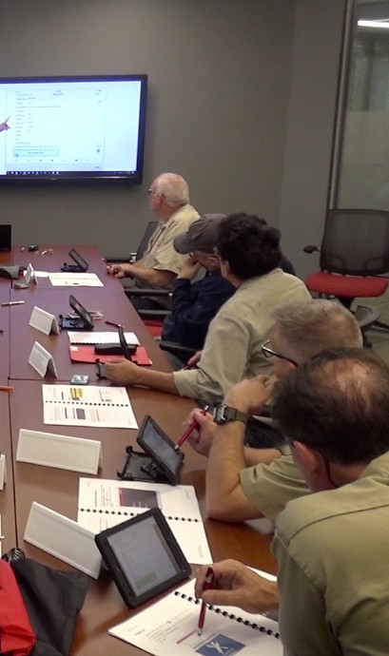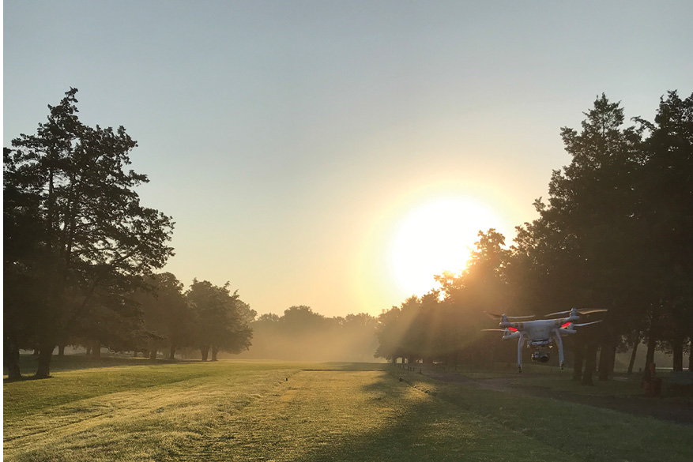

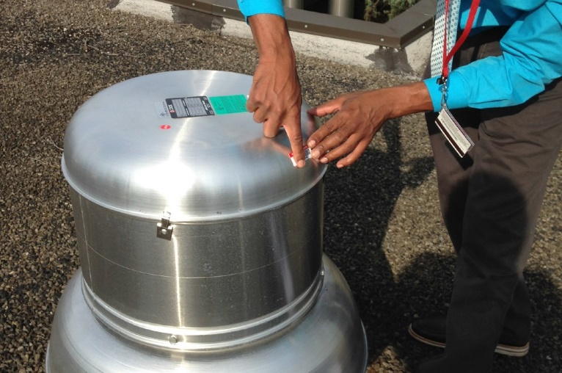
July 1, 2026

TABLE OF CONTENTS

1.0 Service Level Agreement Overview 1
2.0 Description of Services 1
3.0 Service Costs 3
4.0 Service Provider Responsibilities 3
5.0 Problem Management 4
6.0 Key Performance Indicators and Metrics 5
7.0 Periodic Review Process 5
8.0 Out of Scope Services 5

1.0 SERVICE LEVEL AGREEMENT OVERVIEW

This Service Level Agreement (SLA) is intended to identify the basic services, and any agreed upon optional services provided by Strategic Services. The services provided are primarily internal to Institutional Planning and Operations’ (IP&O) support of its mission services however, are also available to the entire university community.

This SLA covers the period from July 1, 2026 - June 30, 2027, and will be reviewed and revised at the end of this period.

- DESCRIPTION OF SERVICES

Strategic Services is responsible for coordinating and uniting the efforts of IP&O individual units statewide. Strategic Services collects and provides valuable data that drives current decisions about operational efficiencies, as well as aiding future planning.

This department primarily provides a host of services to the departments which fall under the IP&O divisional umbrella:

    - IWMS Administration, is responsible for optimizing the practical use of workplace computerized system resources, providing the best possible user experience when interacting with those resources, evaluating and choosing the best systems and managing the physical asset portfolio across the entire division of IP&O.

In support of these responsibilities, IWMS Administration’s team of professionals support three interrelated units and that interact with all internal and external partners to develop and implement initiatives:

      - The Facilities Condition Analysis group collects and manages the asset and assessment database statewide, an inventory of over 50,000 items. The data is used by decision makers up to and including cabinet-level positions. This group also decommissions and removes from service older or outdated assets and catalogs new assets resulting from construction and renovations. This ensures that a vigorous preventive maintenance program is followed offsetting the need for emergency repairs which require the often disruptive and sudden diversion of staff and capital resources.
      - The IP&O Systems Control and Support group is a unified and centralized office that supports IP&O system end-users. Via ServiceNow, it is the primary recipient, of IP&O staff questions, inquiries, and issues related to the IWMS systems’ end-user experience. Case management requests may include, but are not limited to system onboarding, role and permission provisioning, and configuration system changes to align with changes in IP&O business processes.
      - IP&O Service Center is responsible for directing the workflow of all work requests across all 28 departments/functional areas within the Division of IP&O. As a group within IWMS Administration, IP&O Service Center unifies the functions related to the intake, processing and dissemination of information and

data connected to IP&O services on one work platform using the ServiceNow customer portal. This center will serve and impact a global university community of 80,000 people, thus aligning with strategic goals to bring clarity, simplicity, and ease when accessing services provided by IP&O.

    - Communications and Marketing department within Strategic Services disseminates information through multiple channels of traditional and internet-based communication avenues for our employees and for the greater university. General news is found in the division newsletter (https://ipo.rutgers.edu/inside-ipo). The group also runs the division’s social media pages including Facebook, Twitter, and Instagram. It maintains a repository of videos and podcasts which can be found on the IP&O YouTube channel. Communications and Marketing works closely with all divisional groups to help brand and market its projects. This group also liaises frequently with other university communications groups to which it lends its services:

      - Photography
      - Internal Branding
      - Videography
      - Creative/Design Services
      - Drone photography/videography
      - Tutorial videos
      - New Product /New Service Roll out
      - Marketing efforts
      - Social Media posts
      - Social Media Advertising
      - Writing & Editing
      - Presentation Preparation
      - IP&O Web Development
      - Podcasts

    - IP&O Administration staff IP&O Administration staff manages the administrative functions for Strategic Services and supports the Executive Vice President & COO. This office prepares the F&F Committee documents for the university boards and maintains an archive of all board approved resolutions. This office also manages two resource accounts. Communications received from the university community through the “Contact Us” resource account are routed to the appropriate party within the division for resolution. Also, in collaboration with the VP of Planning, Development, and Design, IP&O Administration manages communications for Projects Requests within the e-builder software and other general university inquiries. IP&O Administration also maintains an archive of the IP&O procedures and guidelines, as well as manages survey distribution.

    - IP&O Data Ecosystem strives to promote a culture of data literacy among IP&O staff Data-supported insights will drive informed decisions. Additionally, this group manages the sourcing and visualizing of data available through the Rutgers University Data Warehouse and other applicable IP&O systems to provide IP&O units with accurate, consistent, and reliable database information in easily accessible reporting formats.

    - myPath Training and Employee Development provides both systems training and employee development programs to ensure that existing IP&O staff are provided growth-focused support, enabling them to reach their workplace potential. The comprehensive training program provides IP&O staff with specific knowledge and skills needed to improve performance. Training delivery modalities include Web-based Training (WBT), Instructor-led Training (ILT), user guides, reference guides, and simulations produced with rapid development software. The employee development component of the department includes a variety of developmental programs that will meet the practical and aspirational goals of IP&O staff. This department will also liaise with other university departments as needed when university-wide training initiatives are identified.

    - Employee Services serves approximately IP&O 2,700 staff, represented by 15 collective negotiations agreements. In partnership with UHR, it is responsible for all facets of the employee lifecycle within IP&O, including, but not limited to, talent acquisition and management, compensation management, transactional employee lifecycle activities, employee relations, strategic organizational support and effectiveness, employee performance management, and strategic initiatives impacting recruitment and retention. It provides guidance and support of HR policies and procedures.

- SERVICE COSTS

Note: “General and Administrative” RCM Metric uses operating expenses to allocate the cost pool. Exclusions include: direct debt, direct utilities, F&A returns and subcontracts.

In developing the fiscal operating budget (Cost Pool), there are numerous assumptions and sensitivities that are addressed including but are not limited to these:

    - Changes in aligned employees collective bargaining agreements.
    - Fluctuation in fringe benefit rates.
    - Rise in contract, equipment and supply costs.

- SERVICE PROVIDER RESPONSIBILITIES

Strategic Services Provides the following services:

    - Photography: Take professional quality photos and editing.
      - Internal Marketing: Promotion of IP&O objectives, products, and services to IP&O staff Videography: Professional quality videos and video editing using applicable software.
      - Drone photography/videography: File all regulatory forms with the FAA and EHS for each Drone usage.

      - Tutorial videos: Create professional quality videos using applicable software to teach, explain, or demonstrate a process, application, or task.
      - New Product/New Service Roll Out: Develop a campaign which encompasses graphic imagery and associated communications to market the product or process to the targeted group. This may be a one-time campaign or have multiple rollout phases.
      - Social Media Posts: Ensure that Social Media posts are current, informative, and accurate, and then monitor the reach and success of these posts.
      - Social Media Advertising: Ensure that Social Media advertising efforts are targeted to the correct group and follow the success of these ads using data analytics.
      - Writing & Editing: Ensure that all communications are concise, grammatically correct, and follow university style guidelines.
      - Presentation Preparation: Ensure that all presentations communicate the subject and topic effectively.
      - Training: Ensure that all training requests follow the ADDIE development model.

5.0 PROBLEM MANAGEMENT

Strategic Services operates collaboratively within our group, as well as with colleagues from other internal IP&O departments and outside of IP&O. Should problems arise, the following contacts are equipped to manage the issues. Unresolved problems will be escalated to the Assistant Vice President.

5.1 Support & Problem Escalation Contact List

Support Contacts for Strategic Services
Madalyn Zayas | Sr. Departmental Administrator for IP&O Administration | 848-445-2476 | Madalyn.zayas@rutgers.edu
Joseph Holtsclaw | Senior Director, IWMS Administration | 848-445-2439 | Joseph.holtsclaw@rutgers.edu
Sue Bhuyan | Director, myPath Training and Employee Development | 848-445-2520 | Sbhuyan@rutgers.edu
Elizabeth Crann | Senior Director, Communications & Marketing | 848-445-2401 | Elizabeth.crann@rutgers.edu
Sarah N. Difrancesco | Assistant Director, Employee Services | 848-445-2817 | Sarah.difrancesco@rutgers.edu
Robert Perez | Systems Prgmr/Admins | 848-445-2657 | R.perez@rutgers.edu
Escalation Contact
Ghislaine Darden | Associate Vice President | 848-445-2478 | Ghislaine.darden@rutgers.edu

- KEY PERFORMANCE INDICATORS AND METRICS

    - Number of assets entered into the system
    - Training evaluation surveys
    - Website Analytics
    - Intranet Analytics
    - Social Media Analytics
    - Number of IP&O ServiceNow cases

7.0 PERIODIC REVIEW PROCESS

This SLA is a living document and will be reviewed and updated at a minimum of once per fiscal year. Contents of this document may be amended as required, provided mutual agreement is obtained and communicated to all affected parties. Strategic Services will incorporate all subsequent revisions and obtain mutual agreements/approvals as required.

8.0 OUT OF SCOPE SERVICES

Strategic Services does not charge the university community for any service.

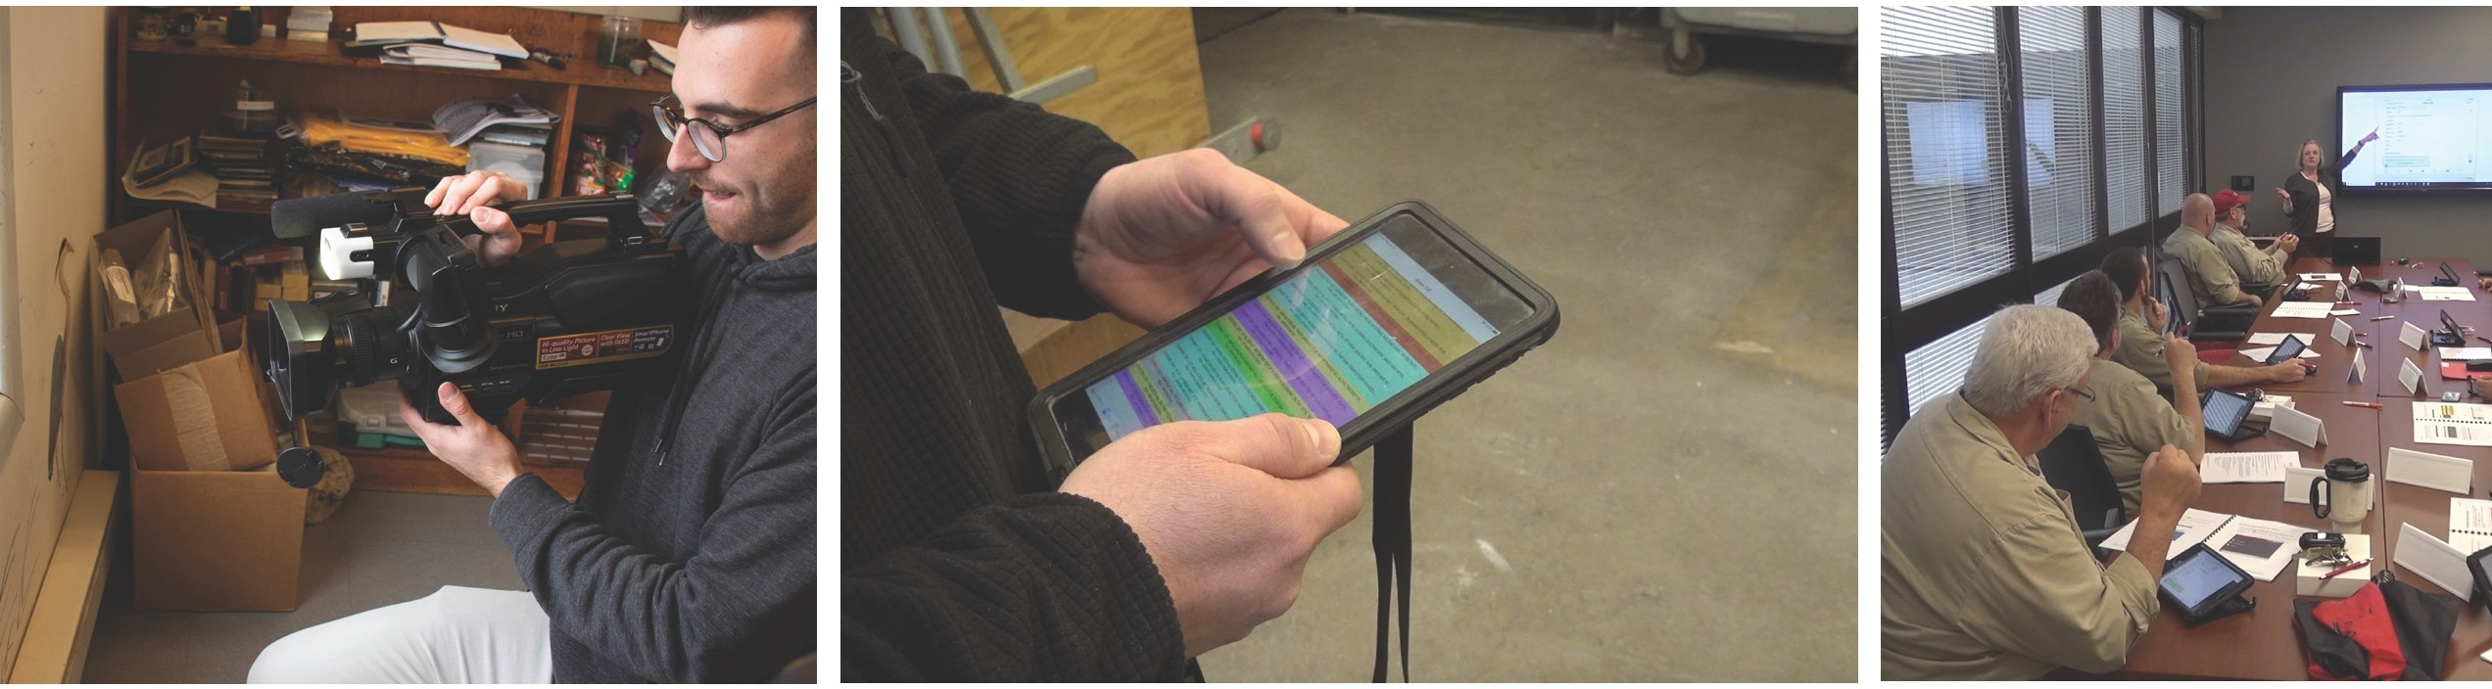

SUPPORTING TODAY, ENVISIONING TOMORROW.

