

Service Level Agreement

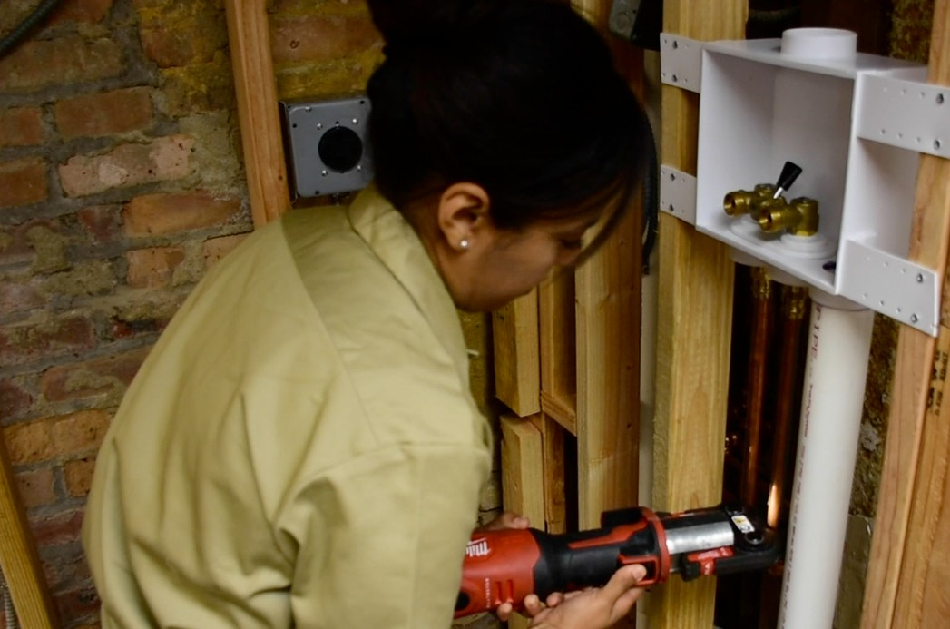
University Facilities

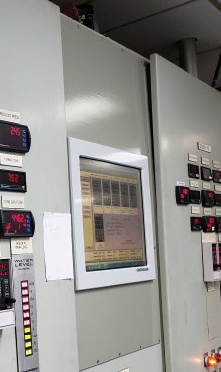
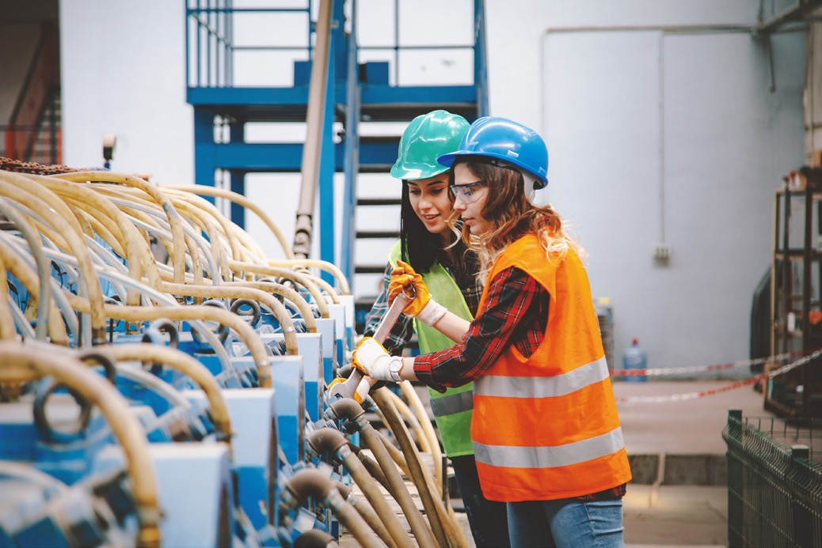
July 1, 2026

Table of Contents

- Service Level Agreement Overview 1
- Description of Services 1
- Service Costs 5
- Service Provider Responsibilities 5
- Problem Management 7
- Key Performance Indicators and Metrics 10
- Periodic Review Process 10
- Out of Scope Services 11

- SERVICE LEVEL AGREEMENT OVERVIEW
This Service Level Agreement (SLA) is intended to identify the basic services, and any optional agreed upon services provided by University Facilities. University Facilities is comprised of Facilities Operations (Custodial/Housekeeping, Maintenance and Grounds), Facilities Infrastructure (Utilities O&M) and Construction/Renovation Project Management.

This SLA covers the period from July 1, 2026 - June 30, 2027, and will be reviewed and revised at the end of this period.

- DESCRIPTION OF SERVICES

The following represents the baseline services as currently provided by University Facilities. Environmental Services
Baseline services provide a hazard free environment and cleaning services to all academic, research and administrative buildings as well as enhanced services in clinical areas as/where required. Range of services includes building entrances, elevators, stairwells, corridors, bathrooms, common area kitchens, lounges, faculty and staff offices, classrooms and other miscellaneous areas. Services include:

- Floor Care
- Recycling/Trash Removal
- Clean/Sanitize
- Provide Soap, Plastic Bag and Paper Products for Bathrooms/Kitchens

The baseline services are funded from the O&M cost pool. Services outside the day-to-day scope are available at an additional cost (see section 8.0).

Task | Entrances, Public Areas, Corridors and Common Area Kitchens | Private Offices | Research Labs | Auditoriums, Classrooms, Computer Labs, Teaching Labs, Lecture Halls | Seminar Rooms Conference Rooms, Open Office Areas Staircases and Landings | Clinical, Exam, Treatment Rooms; Public Restrooms
GENERAL
Clean entry area glass | Weekly | N/A | N/A | N/A | N/A | N/A
Dust and clean horizontal surfaces, unencumbered furnishings. | As needed | Monthly | As determined necessary by EVS | As determined necessary by EVS | Weekly | Daily
Clean and sanitize water fountain/bottle fill stations | Daily | N/A | N/A | N/A | N/A | Daily

Task | Entrances, Public Areas, Corridors and Common Areas Kitchens | Private Offices | Research Labs | Auditoriums, Classrooms, Computer Labs, Teaching Labs, Lecture Halls | Seminar Rooms Conference Rooms, Open Office Areas | Clinical, Exam, Treatment Rooms; Public Restrooms
Clean and disinfect fixtures | N/A | N/A | N/A | N/A | N/A | Daily
Clean boards erasers, chalk trays/replenish supplies as needed | N/A | N/A | N/A | While in use | N/A | N/A
FLOOR CARE
Mop floor or vacuum/spot clean floors and carpet | Bi-weekly | As determined necessary by EVS | As determined necessary by EVS | While in use | Weekly | Daily
Restore carpet and floor finishes This is now outside of the SLA | As determined necessary by EVS | N/A | N/A | N/A | N/A | As needed
RECYCLING / TRASH
Empty Trash containers | Daily | Monthly | Weekly | Daily | Weekly | Daily

Building Maintenance
Provides limited routine maintenance and general repair services to the campus inclusive of mechanical/ electrical, heating and cooling, life safety system inspections, glass repair, domestic hot water, plumbing, roof repairs and other building related activities. In addition, various preventive maintenance programs are undertaken on a periodic basis for asset preservation that are carried out through scheduled preventive maintenance programs in accordance with the manufacturer’s recommendations. Only preventive maintenance services are included in the O&M cost pool. Repairs due to age, deferred maintenance and emergency repairs are not included in the O&M cost pool but are billed to the School, Unit and or Chancellor.

Mechanical Maintenance Services are completed by service type.

Emergencies such as adverse weather conditions, and other demands may affect service delivery. For emergency service requests please contact the appropriate Facilities Call Center outlined in Section 5.0.

Renovations and planned projects outside the day-to-day scope are available at an additional cost (see section 8.0).

Priority/Type | Definition | Response Time | Descriptive Text
EXPEDITED SERVICES
Emergencies/ Urgent | Fire, health, and safety items that demand immediate response to protect lives, research activities, and property. | Immediate response to alleviate critical situation. Permanent repair may occur  later. | Unscheduled and/or service work requiring a response to remedy an emergency or urgent situation. Flood, fire, intrusion of wildlife, climate control, water temperature, lighting, and any other  critical situation deemed hazardous. These requests receive priority over all other requests
ROUTINE
Preventive Maintenance | Work that is planned and/or scheduled supporting the University's asset preservation strategy. | As required by regulatory compliance or manufacture's recommendation. | Scheduled planned maintenance to increase system reliability and help decrease system failure. Designed, developed, and implemented on manufacturer's recommendation and industry standards, maximizing equipment life.
GENERAL
Scheduled Maintenance | Normal maintenance or service items that do not pose an immediate risk to life, research activity, property, or systems and equipment. | Within 120 days based on parameters and staffing levels. | Scheduled in-house maintenance to building envelope, equipment, systems, electric and water distribution, or any other repair requiring mechanical maintenance and/or outside contractor support.
ENHANCED
Renovation and Enhanced Services | Customer requests for small aesthetic projects and additional services scheduled for a specific date. | Per mutual agreement | Requests handled on a planned/scheduled basis and are funded by the customer. Advance coordination with the requestor is typically required to allow scheduling of personnel or space, and receipt of materials. Specific date requests should receive a response in a minimum of 10 days after submittal of the request.

Grounds and Roads
Grounds Services are provided to insure a safe, aesthetically pleasing, and clean outdoor environment on all campuses. Emergencies such as adverse weather conditions, other demands and staffing levels may affect service delivery. For emergency service requests please contact the appropriate Facilities Call Center outlined in section 5.0. Services outside the day-to- day scope are available at an additional cost (see section 8.0).

Provides general lawn, shrub and tree care, landscape design and planting, snow removal, storm drain and parking lot maintenance. These services are included in the O&M cost pool.

- Mowing, seeding, watering, fertilizing of lawns and weeding, edging, and blowing off walkways
- Empty trash/recycling containers, pick up litter, clean off graffiti, and sweeping
- Tree pruning, disease monitoring, and tree removal
- Maintaining/watering of shrubs, flowers and other plantings
- Maintaining/cleaning storm drains, fences, retaining walls, flag poles and outdoor furniture
- Snow removal/maintenance of roads, parking lots, and walkways

Task | Building & Mall Areas, Bus Stops, Hardscapes | Low Mow, No Mow, Farms, Meadows
Mowing, weed whip, blow off walks | 18 x per year if needed | As Needed
Edge walks | Quarterly if needed | As needed
Seeding, fertilization; disease & pest control | As needed | As needed
Annual and perennial planting – Limited areas only | Spring & Fall | N/A
Safety pruning of trees and scrubs | As needed | As needed
Empty trash/recycling, pick up litter | 1 – 5 x per week | As Needed
Remove graffiti and non-approved postings | As Needed | As Needed
Maintenance/Cleaning of outdoor furnishings, paths of travel and gathering spaces. | As Needed | Monthly As Needed
Storm water inspections | As Needed | As Needed
Sweeping/maintenance streets and parking lots | Monthly | Monthly
Roadways, sidewalks, parking lots | As needed | As needed

Infrastructure (Utilities O&M)
The Facilities Infrastructure (Utilities O&M) Services group operates the university’s heating, solar array, electrical, Chilled Water, Cooling and water supply plants. It provides a constant presence to operate large equipment and to respond to Facilities emergencies off hours. Utilities procures and distributes energy, heat and cooling, water, gas, and storm water and sewage to/from buildings and land. These services will continue as in prior years but will no longer be funded by the O&M cost pool. As of July 1, 2025 these services will be charged to the University’s Enterprise-Wide Utilities Commodities cost pool.
Utilities also monitors and maintains building controls systems and maintains elevators, lifts and escalators. These services will continue to be funded by the O&M cost pool, except for issues related to deferred maintenance. Deferred maintenance related repairs, upgrades, and or replacement are funded by the School, unit and or Chancellor.

Construction/Renovation Project Management

It is important to note that the services of Construction/Renovations Management are not included or funded by the Cost Pools outlined in Section 3.0. The services outlined below are fee based and funded by the school, unit or Chancellor, see Section 8.0.

Construction/Renovation Project Management Services provides comprehensive professional construction project administration services to the university community for all University owned facilities enterprise wide. Two units within University Facilities manages projects, Project Services and Renovations and Infrastructure.

Project Services manages large projects exceeding $5 million on all campuses and projects under $5 million for Rutgers Health and Newark. Renovation and Infrastructure manages projects under
$5 million for New Brunswick, and Camden.

- SERVICE COSTS
Note: “Operations and Maintenance” RCM Metric uses space data from Archibus. O&M costs are determined for all units based on the unit’s proportional share of space. Cost centers O&M costs are then allocated to the responsibility centers based on the appropriate cost pool allocation.

Note: “Utilities” RCM Metric: Building utilities are allocated directly to the building occupants based on the proportional share of space they occupy. Metric used is space data from Archibus. Cost centers’ utilities costs are then allocated to the responsibility centers based on the appropriate cost pool allocation. Remaining utility expense, not directly charged, are allocated via the G&A metric.

In developing the fiscal operating budget (Cost Pool), there are numerous assumptions and sensitivities that are addressed. These include but are not limited to:
- Variations in energy consumptions associated with the uncertain northeast climate.
- Worldwide energy commodity cost fluctuations associated with demand and supply considerations including electricity, natural gas, and oil.
- The continuing escalation of deferred maintenance resulting from an aging facilities and utilities infrastructure and a rise in annual work order requests.
- Changes in aligned employees collective bargaining agreements.
- Fluctuation in fringe benefit rates.
- Rise in contract, equipment and supply costs.
- Unforeseen natural disasters and public safety events.
- State and Federally mandated regulatory requirements.

Service Provider Responsibilities
Environmental Services is responsible for cleaning and maintaining more than 24 million square feet of space in over 1,000 buildings. The frequency with which these services are provided is contingent upon the area being cleaned and activity levels. For example, restrooms are routinely cleaned and inspected throughout the day. Trash and recycled bins must be emptied by the occupant. Emergencies such as adverse weather conditions, and other demands may affect service delivery. For emergency service requests please contact the Facilities Call Center at 848-445-1234. Services outside the day-to-day scope are available at an additional cost (see section 8.0).

Environmental Services Operations Service Types

STANDARD
Environmental Services standard practices are at a reduced commercial property level of cleanliness, sanitation, safety, and aesthetics. EVS’ tasks and frequency standards are currently accepted throughout the Professional Custodial Industry.

SPECIALIZED
Environmental Services that are provided as a specialized service beyond the normal day to day activity. Services may include detailed cleaning of clinical spaces required to maintain regulatory compliance, assistance with pest control or clean-up from emergency situations such as a flood, fire or vandalism.

Mechanical Maintenance Operations Service Types

STANDARD
Emergency and urgent response to alleviate, isolate, and contain a critical situation and to eliminate the risk of further deterioration. Routine preventative maintenance and service to the building envelope, equipment and systems that do not pose an immediate risk. Includes work that can be responded to on a planned and scheduled basis.

SPECIALIZIED
Routine preventative maintenance, regulatory compliance, life safety, fire/sprinkler code compliance, environmental safety and services to equipment and systems that do not pose an immediate risk. Includes work that can be responded to on a planned and scheduled basis.

Grounds Operations Service Types

STANDARD
Grounds maintenance standard practices are at a reduced commercial property level for cleanliness, safety, security, and aesthetics. Grounds Services tasks and frequencies will adequately address the landscape maintenance needs of the university.

SPECIALIZED
Specialized maintenance practices are designed to show case the natural beauty of site features, vegetation, and to sustain ecosystems. Intensive establishment procedures may span several years for naturalistic plantings such as meadows, low mow, and no mow areas where maintenance is less frequent.

Infrastructure (Utilities O&M) Services

- Constant Presence: Equipment Operators and Mechanical coverage are on site 24 hours per day, seven days per week to operate large equipment such as boilers, chillers, cooling towers, and cogeneration equipment; perform general inspections of Utilities equipment; and respond to Facilities emergencies and assist Campus Safety off hours.
- Energy Procurement and Monitoring: Manage procurement of electricity, natural gas, and water.
- Central Plants and Distribution: Maintain, repair, and operate numerous central plants providing hi-temp hot water, domestic hot water, chilled water, and electricity. Also includes maintenance and repair of hot water, chilled water, domestic water, storm water and sewage pipes and related structures. Electrical distribution includes aerial and buried electrical cables, numerous substations and transformers, and solar fields.
- Building Monitoring Systems and Sustainability: Maintain and repair building monitoring systems to track energy use and make adjustments to major equipment remotely. Promote energy conservation and support sustainability initiatives.
- Elevators: Manage the maintenance, repair and upgrades for all elevators at the University.

- PROBLEM MANAGEMENT

Service issues are directed to the Facilities Call Center during business hours or to Rutgers University Police Department off hours. Significant or unresolved issues will be raised to the level as noted in section 5.1.

- Web – http://facilities.Rutgers.edu/submit -a-maintenance-service-request-NEW
- Call Center 848-445-1234, 8:00am – 4:30pm, Monday – Friday
- Afterhours, weekends and holidays 848-932-7211

  - SUPPORT & PROBLEM ESCALATION CONTACT LIST – CLASSROOMS, LABS, CLINICS, INSTITUTES, CENTERS AND ADMINISTRATIVE BUILDINGS

Support Help Line Facilities Operations
Name | Role | Phone | Email
Service Call Center NB/P | Work Control NB/P 8:00AM – 4:30PM, M-F | 848-445-1234 | https://apps.ufcp.rutgers.edu/CR/Login?ReturnUrl=% 2fcr
Service Call Center Rutgers Health  NB/P | Work Control Rutgers Health Central NB  WORK CONTROL Rutgers Health CENTRAL P 8:00AM – 4:30PM, M-F | 732-235-6210  732-235-4663 | https://apps.ufcp.rutgers.edu/CR/Login?ReturnUrl=% 2fcr
RUPD  NB/P | After Hours/Weekends  4:30pm-8:00am NB/P/ Rutgers Health CENTRAL NB/P | 848-932-7211 | N/A
Service Call Center  NEWARK | Work Control Newark 8:00AM – 4:30PM, M-F | 973-353-5441 | https://apps.ufcp.rutgers.edu/CR/Login?ReturnUrl=% 2fcr
RUPD  NEWARK | AFTER HOURS/WEEKENDS 4:30pm-8:00am Rutgers Health NEWARK/NEWARK | 848-932-7211 | N/A
Service Call Center  CAMDEN | Work Control Camden 8:00AM - 4:30PM, M-F | 856-225-6300 | https://apps.ufcp.rutgers.edu/CR/Login?ReturnUrl=% 2fcr
RUPD  CAMDEN | AFTER HOURS/WEEKENDS 4:30pm-8:00am -  Camden | 856-225-6111 | N/A
Support Contacts Facilities Operations
Nicole Catalano | Operations Coordinator NB/P/ Rutgers Health Central | 848-445-3794 | nicole.catalano@rutgers.edu
Rona Lehtonen | Director NB/P/Rutgers Health Central | 848-445-2851 | rona.lehtonen@rutgers.edu
Yohanna Alcantara | Assistant Director Newark | 973-353-1177 | yohanna.alcantara@rutgers.edu
Name | Role | Phone | Email
Gary Formisano | Facility Manager Rutgers Health Newark | 848-200-8002 | gary.formisano@rutgers.edu
Nick Matteo | Operations Coordinator Camden | 856-225-6300 | camdenfms@ipo.rutgers.edu
Escalation Contacts – Level 1 Facilities Operations
Samuel Parada | Associate Director CAC/B (Acting Position) | 732-433-4356 | samuel.parada@rutgers.edu
Jeffery Williams | Associate Director C/D- L | 848-565-0399 | jeffery.williams@rutgers.edu
John Fata | Group Manager Rutgers Health Central | 732-773-4465 | fatajj@ipo.rutgers.edu
Camden Boiler Room | Shift Person On-Duty | 856-225-6206 | N/A
Chris Small | Area Manager Camden | 732-433-1003 | c.small@rutgers.edu
Escalation Contacts – Level 2 Facilities Operations
Vacant | Senior Director NB/P
Wayne Persad | Senior Director Rutgers Health NWK/Newark | 848-336-0415 | wp204@ipo.rutgers.edu
Christopher Pepsin | Director Rutgers Health Central | 732-770-6075 | pepsincj@ipo.rutgers.edu
Michael Fitzgerald | Associate Director Camden | 848-239-0456 | mike.fitzgerald@rutgers,edu
Escalation Contacts – Level 3 Facilities Operations
Michael Manchello | Associate Vice President | 848-445-3705 | michael.manchello@rutgers.edu
John Shulack | Vice President | 848-445-2460 | john.shulack@rutgers.edu
Support Help Line Infrastructure (Utilities O&M) Services
Facilities Service Call Center | Business Hour Response | 848-445-1234 | N/A
Name | Role | Phone | Email
Support Contacts Infrastructure (Utilities O&M) Services
Rutgers Police | Off Hours Response | 732-932-7211 | N/A
Theodore Elonis | Outside Plants and Building Services | 848-445-0299 | theodore.s.elonis@rutgers.edu
Robert Williams | Power, Heating, Cooling Plants | 848-207-7954 | robert.e.williams@rutgers.edu
Escalation Contacts Infrastructure (Utilities O&M) Services
Janice L Davey | Renovation and Infrastructure Services | 848-445-2466 | janice.l.davey@rutgers.edu
John Shulack | Vice President | 848-445-2460 | john.shulack@rutgers.edu
Support Contacts Construction / Renovations Project Management
John M. Fritzen | Director, MEP | 848-445-2842 | john.fritzen@rutgers.edu
Chris J. Hack | Director, Architectural | 848-445-2844 | chris.hack@rutgers.edu
Zaydie Rodriguez- Chadwick | Assistant Director, Renovations | 848-445-2485 | zaydie.chadwick@rutgers.edu
Matthew Schott | Acting Director, Rutgers Newark Projects | 973-534-7717 | matthew.schott@rutgers.edu
Shailesh “Shai” Patel | Director, Rutgers Health Projects | 848-445-2258 | shai.patel@rutgers.edu
Escalation Contacts Construction / Renovations Project Management
Janice L. Davey | Assistant Vice President  UF-R&I | 848-445-2466 | janice.L.davey@rutgers.edu
Nicholas L. Fabbroni | Assistant Vice President UF-PS | 848-445-2286 | nick.fabbroni@rutgers.edu
John Shulack | Vice President | 848-445-2460 | john.shulack@rutgers.edu

- KEY PERFORMANCE INDICATORS AND METRICS

Facilities Operations:

- Facilities survey results
- Preventive maintenance work orders processed
- Service work orders processed
- Service received response
- Cleanliness satisfaction
Infrastructure (Utilities O&M)

- Reliability of provision of utilities
- Incident response time
- Impairments
- Notifications

7.0 Periodic Review Process

This SLA is a living document and will be reviewed and updated at a minimum of once per fiscal year. Contents of this document may be amended as required, provided mutual agreement is obtained and communicated to all affected parties.

Out of Scope Services

For service requests, which are determined to be enhanced (fee based), billable rates will be based on labor hourly rates plus material. The labor rate will be established each year and subject to change caused by collective bargaining settlements and fringe benefit increases. The service unit will provide an estimate of costs to the requesting unit and the requesting unit will issue an internal purchase order or transfer funds based on the estimate prior to the service unit commencing the work. A final invoice will be issued at the end of the work.

Examples of an enhanced service for Facilities Operations:

- Items added to offices such as outlets or lighting not included in the original design
- Services within specialized labs and vivariums
- New carpet or painting prior to scheduled replacement
- Window washing
- Special plantings
- Interior building signage

ENVIRONMENTAL ENHANCED SERVICES

Departmental requests outside standard services are funded by the customer and can be arranged using the on-line ENHANCED SERVICES request form available through the Rutgers University Facilities website.

MECHANICAL MAINTENANCE OPERATIONS ENHANCED SERVICES

Departmental requests outside routine maintenance, such as expedited paint, carpet removal/installation, and minor projects, are handled on a planned and scheduled basis and funded by the customer. Requests require advanced coordination and can be purchased using the on-line ENHANCED SERVICES request form available through the Rutgers University Facilities website.

GROUNDS OPERATIONS ENHANCED SERVICES

Departmental requests and increased frequencies outside standard services are funded by the customer and can be arraigned using the on-line ENHANCED SERVICES request form available through the Rutgers University Facilities website.

Billable rates will be based on labor hourly rates plus material (if materials are needed). The labor rate will be established each year. The service unit will provide an estimate of costs to the requesting unit and the requesting unit will issue an internal purchase order or transfer funds based on the estimate prior to the service unit commencing work. A final invoice will be issued at the end of the work.

CONSTRUCTION / RENOVATION PROJECT MANAGEMENT

Construction/Renovation Project Management Services are responsible for the construction of new facilities and renovations to existing facilities. Services include developing the scope and cost of the requested work, design of the project utilizing outside consultants or facilities design professionals, selection of and bidding for construction contractors, commissioning of the building and coordination and relocation of occupants. This group also handles construction contract administration. The group consists of experienced planning, design and construction professionals who interact with vendors, customers and other university service departments.

- Programing: Interview client and compile space needs.
- Schematic Design: Block & Stack and layout space needs.
- Design Development: Advance Architectural/Engineering design.
- Construction Documents: Create design documents for bidding.
- General Contractor Bidding or Design Build Proposals: Facilitate the procurement process.
- Construction: Manage the AE, Contractor and Owner’s Representative. Attend meetings, procure FF&E and on site supervision.
- Commissioning: Assure major equipment operates to optimal design standards.

ALL construction, emergency repairs, renovations, deferred maintenance and building demolishing are out of scope and it is the responsibility of the requesting unit or Chancellor area to fully fund.
Please contact Facilities for additional details.

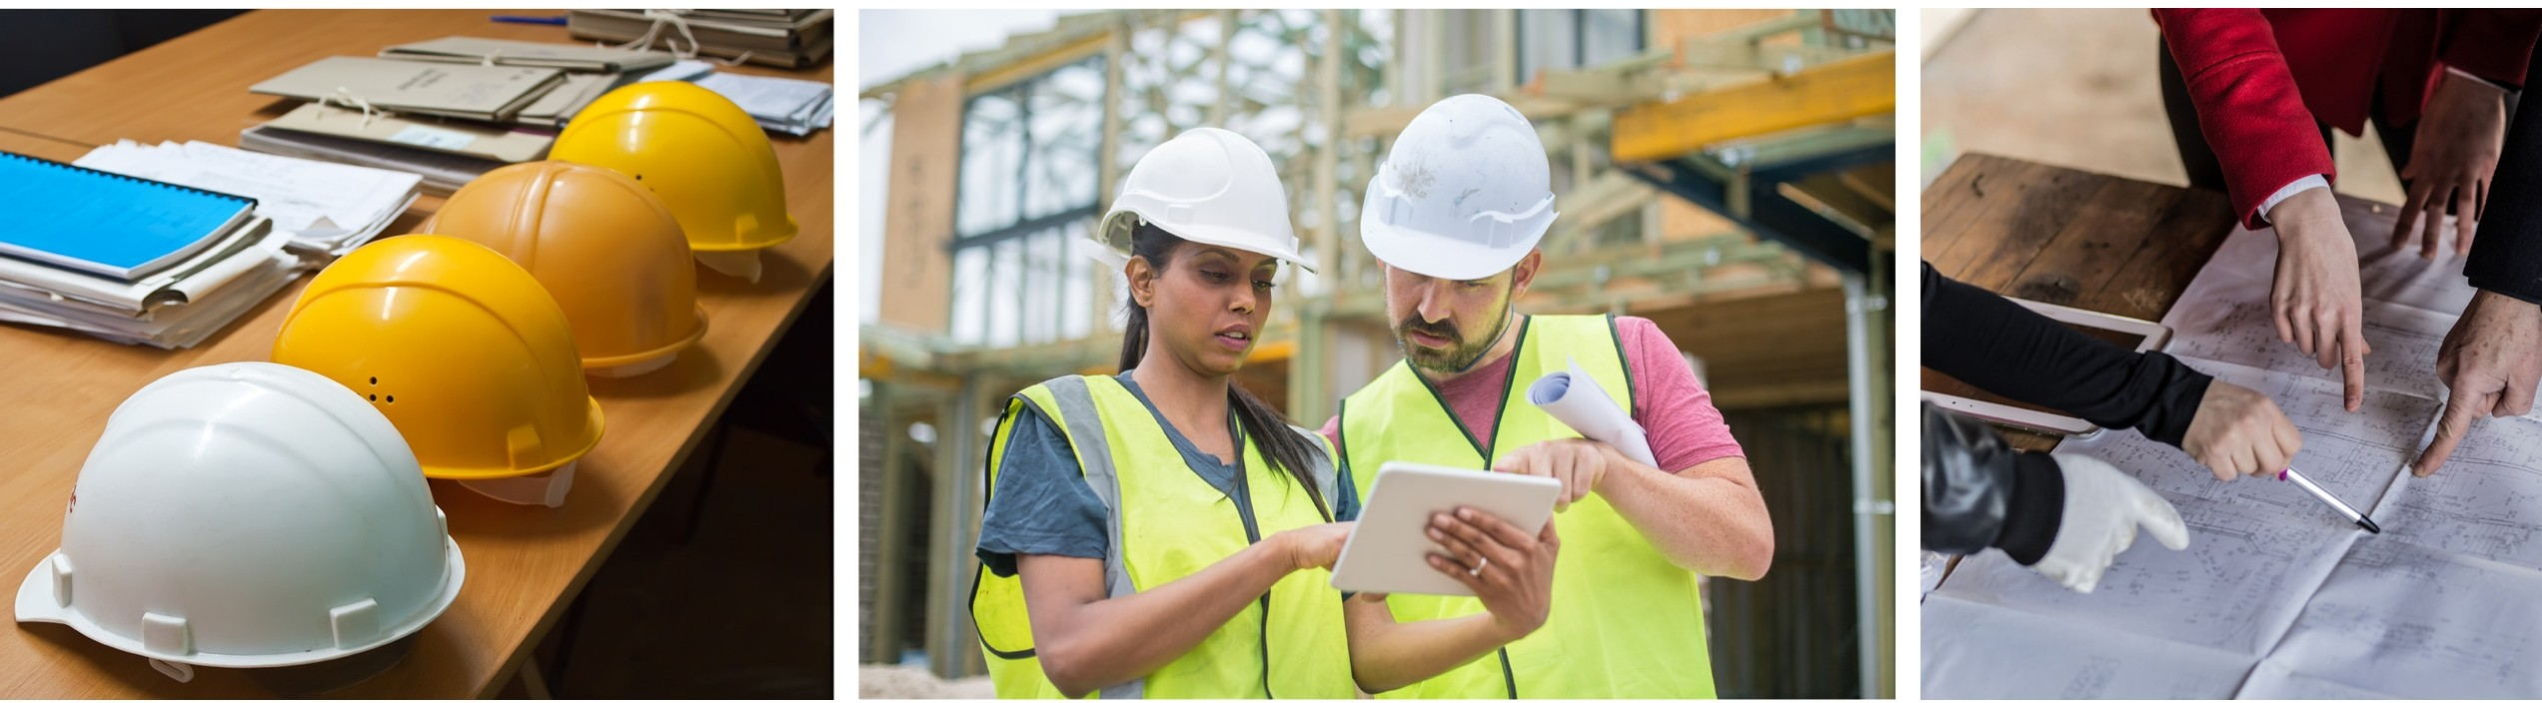

SUPPORTING TODAY, ENVISIONING TOMORROW.

