

Service Level
Agreement

Planning, Development, and Design

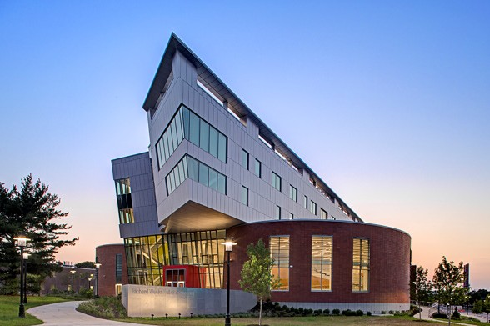

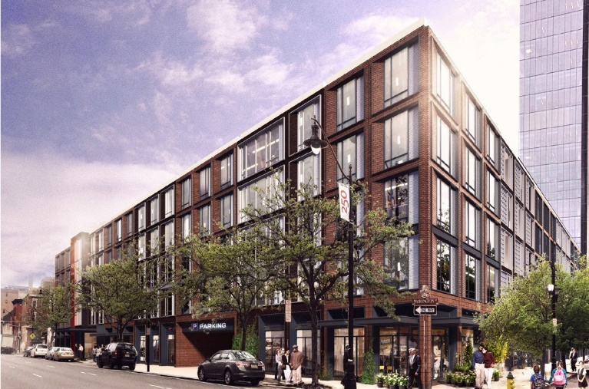
July 1, 2026

TABLE OF CONTENTS

1.0 Service Level Agreement Overview 1

2.0 Description of Services 1

3.0 Service Costs 3

4.0 Service Provider Responsibilities 3

5.0 Problem Management 7

6.0 Key Performance Indicators and Metrics 7

7.0 Periodic Review Process 8

8.0 Out of Scope Services 8

1.0 SERVICE LEVEL AGREEMENT OVERVIEW

This Service Level Agreement (SLA) is intended to identify the basic services, and any agreed upon on-demand services provided by Planning, Development, and Design (PD+D). PD+D integrates the areas of planning, development, real estate, design, environmental graphics, space management, and construction technology to promote a more holistic approach to planning at the university. The department is charged with balancing efficient programming with thoughtful design to create an evolving, safe, functional, and inviting environment that advances the university's institutional mission.

This SLA covers the period from July 1, 2026 - June 30, 2027, and will be reviewed and revised at the end of this period.

- DESCRIPTION OF SERVICES

There are four (4) functional areas within PD+D, and three (3) of the areas provide both basic services (see Section 4.0) and “on-demand” optional, or out-of-scope services (see Section 8.0). These functional areas, with primary responsibilities indicated, are:

University Architect
    - Special projects (i.e. developer/P3 projects, large-scale donor projects)
    - Architecture/Engineering prequalification and procurement
    - Healthcare partner facilities/legal committees and projects

Planning and Development
    - Master, Capital, and Transportation Planning
    - Landscape architecture and stormwater management
    - Real Estate
    - Geographic Information System/Campus maps

Architecture and Design
    - Architectural and interior design
    - Environmental graphics and signage
    - Design and construction technology
    - Historic preservation

Space Management
    - Archibus space management platform
    - Drawing records/virtual plan room

There is significant interwoven roles and responsibilities among the functional areas, but limited overlap, to maximize efficiencies. Services are provided by a staff of professionals including registered architects, professional engineers, licensed landscape architects, professional planners, real estate professionals, interior designers, graphic artists, and certified building envelope consultants.

A general description of services for each area follows.

University Architect

The University Architect prequalifies professional architectural and engineering consultants, administers the Request for Proposal process to procure professional architectural/engineering and related technical services, and holds signature authority for all architectural and engineering projects. The office leads development projects where a third-party developer will be engaged to work with the university and is an active participant in working with the Foundation for major capital donations. Finally, the office offers support to Rutgers Health and its schools and units for specialized planning for projects associated with University Hospital and RWJBarnabas.

Planning and Development

Planning and Development, working closely with leadership of the university, is responsible for the development of the university capital plan and defining the long-range physical vision of each of the university campuses. This office is engaged at the headwaters of all major capital projects and works with the end users, University Facilities, and PD+D Architecture and Design to develop the initial scope, site selection, and programming of the project. This office interfaces with external agencies in the review, coordination and monitoring of capital projects undertaken by utility companies, adjacent property owners, and state, county and municipal authorities undertaking public right of way improvements that impact the university. The office ensures that university capital construction projects are properly environmentally permitted and in compliance with environmental regulations.

This office is responsible for the campus maps and geographic information system (GIS) platform, which feeds data to other university systems (such as 911 dispatch) and houses data and graphics associated with campus utilities systems. The office is also responsible for administration of all real estate transactions for the university (leases, licenses, easements, etc.).

Architecture and Design

Architecture and Design leads programming and conceptual design efforts, manages feasibility studies and vision documents, leads interior design projects, and ensures aesthetic and sustainability standards are followed throughout the university. This office provides guidance to university customers, assists researchers in the development of grant proposals, maintains signage and wayfinding manual, and serves as stewards of the built environment for the university.

This office is also charged with developing and enforcing standards of quality, functionality, efficiency, maintainability, and compliance in all statewide university construction and renovation projects. Staff conducts detailed reviews of all design and construction project documents, establish and maintain university design standards and guidelines, and advises all project stakeholders on technical and other design issues throughout the life of each project.

Space Management

Space Management is responsible for documentation and management of data associated with 30 million gross square feet of owned and leased space on and off Rutgers University campuses and ensures that university space allocations are documented to accurately reflect uses associated with the university's academic, research, and clinical missions.

This office is also responsible for maintaining physical and virtual building and site drawings, from the newest lab building to Old Queens.

- SERVICE COSTS

Note: “General and Administrative” RCM Metric uses operating expenses to allocate the cost pool. Exclusions include direct debt, direct utilities, F&A returns, and subcontracts.

In developing the fiscal operating budget (Cost Pool), there are numerous assumptions and sensitivities that are addressed. These include but are not limited to:
    - Changes in aligned employees collective bargaining agreements.
    - Fluctuation in fringe benefit rates.
    - Rise in contract, equipment and supply costs.

- SERVICE PROVIDER RESPONSIBILITIES

As described in Section 2.0, there are four (4) functional areas within PD+D, each with basic services. Basic services include, but are not limited to, the following:

University Architect

    - Special projects (i.e. developer/P3 projects, large-scale donor projects)
    - Architecture/Engineering prequalification and procurement
    - Healthcare partner facilities/legal committees and projects

Planning and Development

    - Maintenance and update of the on-line campus map as a resource for the entire university community
    - Oversee process for plaques, monuments, major markers and artwork
    - Secure environmental permits
    - Planning of regional storm water management infrastructure
    - Maintain archival real estate records and procuring leases for new space
    - Maintain the institutional capital plan and physical master plan
    - Participation in campus committees
    - Serve as the university’s liaison to state, county and local government agencies

Architecture and Design

    - Maintain and update the University Wayfinding and Signage Manual
    - Develop and enforce the Design Standards Manual
    - Conduct detailed reviews of all design and construction project documents
    - Provide initial consultation and assessment of planning, design, and code related Project Request Forms
    - Act as stewards of the university’s historic properties
    - Provide interior design, including furniture and finish assistance

Space Management

    - Administer accurate data tracking of all university space
    - Maintain and update all university drawings - current and archived
    - Provide data feeds and reports of all space data to various departments Details of these bulleted items follows:

University Architect

- Provide services associated with special projects such as planning and design information associated with negotiations with potential large-dollar donors, planning for P3 (public/private partnerships), planning and negotiations with developers, and unique or confidential deliberative projects with and on behalf of university senior leadership
- Manage the university’s roster of prequalified architects, engineers, technical consultants so as to have consultants readily accessible to staff of Planning, Development, and Design and University Facilities
- Administer procurement of architects and engineers via Request for Proposal process and administer procurement of developers via Request for Information process
- Provide support and guidance to university constituents on projects and initiatives associated with the university’s healthcare partners by providing active participation and expertise in planning and facilities components of leases, licenses, and affiliation agreements

Planning and Development

- Provide services related to the maintenance and update of the on-line campus map as a resource for the entire university community. On-line campus maps are outward facing, assisting visitors and the public with wayfinding around campus, but GIS, the backbone of the mapping system, also forms a critical, enhanced platform on which a number of internal IP&O operations have built their services, including the emergency response and 911 system, as well as the centralized utilities database
- Provide services relating to the implementation of plaques, monuments, and artwork in a manner consistent with university policy across RU-NB/Rutgers Health (while serving in advisory capacity for RU-N, RU-C)
- Provide services for acquiring environmental permits for capital projects and work with various agencies that enforce regulations pertaining to issues including, but not limited to soil erosion and sediment control, stormwater management, freshwater wetlands, reforestation, dredging, and dam safety

- Provide services pertaining to planning and implementation of comprehensive stormwater management infrastructure on campus that is consistent with the long range physical plan, but also moves away from less effective, piecemeal, building centric solutions
- Provide services relating to the maintenance of real estate records for all 6,064 acres of university lands statewide, including annual filing of tax exemptions to dozens of municipalities
- Provide services related to the administration of leases for space off-campus, including negotiation for best terms, and renewing or sunsetting said leases when necessary
- Provide services maintaining and updating the institution’s capital plan and physical master plan in accordance with the university strategic vison, evolving academic and administrative needs, and upon implementation of capital projects, monitoring their development for consistency with the physical plan
- Provide services related to outreach and liaison with state, county and local government agencies, on matters pertaining to physical planning and development, including the NJ Treasury - Office of Management and Budget, New Jersey Department of Transportation, NJ Department of Environmental Protection, Middlesex County Transportation Coordinating Committee, as well as local land use boards, planning boards and historic commissions
- Provide representation on standing and ad-hoc committees, including:
  - University Naming Committee (staff)
  - Climate Action Operational Steering Committee
    - Sub Committee: Land Use and Building Design Climate Action Group
  - RU-New Brunswick Space Committee
  - RU-New Brunswick Plaques, Monuments, Major Markers and Artwork Committee (chair)
  - RU-NB Strategic Enrollment Planning Committee
  - RU-Newark Space Committee
  - RU-Newark Community Arts Advisory Board

Architecture and Design

- University Wayfinding and Signage Manual: Maintain and update the university wayfinding, signage, and donor recognition standards to implement a strong visual identity across all University properties, districts, and campuses. Provide professional design services, using these standards, to design, procure, and coordinate installation of wayfinding, signage, plaques, and environmental graphics
- Design Standards Manual: Develop and enforce the Design Standards Manual which provide guidelines for the quality, functionality, efficiency, maintainability, and compliance in all university construction and renovation projects. The Design Standards Manual is used by architectural and engineering consultants, contractors, and university staff involved in design, new construction, and renovation of university facilities, systems, and properties
- Design and Construction Project Documents Review: Provide detailed reviews of design and construction project documents to maintain university design standards and guidelines, and advise project stakeholders on technical, code and other design issues

throughout the life of each project. Prior to construction, designs for repair, renovation, alteration, and new construction are subject to a final review, and if approved the documents are then signed by the University Architect
- Initial Consultation and Assessment: Provide consultative professional services related to planning, design, and code related Project Request Forms to assist the customer in determining the project type (i.e. Feasibility Study, Vision Document, Renovation Project, Addition, New Construction Project, Grounds Project, Utilities Project, etc.)
- Historic Preservation: Act as steward of the university’s historic properties. A preservation architect on staff reviews all proposed work at sites and buildings on the State and National Registers of Historic Places and liaises with local historic commissions in Camden and Newark as well as the State Historic Preservation Office
- Interior Design: Provide interior design services including furniture, finish and layout plans. Estimate budgets. Review specifications assist with procurement. Coordinate delivery and installation
- Provide representation on standing and ad-hoc committees, including:
  - Climate Action Operational Steering Committee
    - Sub Committee: Land Use and Building Design Climate Action Group
    - Sub Committee: Energy and Buildings Climate Action Group
  - RU-New Brunswick Facilities Access Council
  - RU-New Brunswick Space Committee
  - RU-New Brunswick Plaques, Monuments, Major Markers and Artwork Committee
  - RU-Newark Space Committee
  - RU-Newark Community Arts Advisory Board

Space Management

- Administer accurate data tracking of all university space: Provide regular review and accurate tracking of all university space data which includes: information on all owned leased or affiliated university buildings, relevant information on leased space, regular room ownership updates, employee location information, audits of renovated space and new construction, and interaction with space representatives from all chancellor offices and academic deans' offices university-wide. Participate as key member in ad hoc meetings as it pertains to university space data
- Maintain and update all university drawings - current and archived: Maintain accuracy of all university floor plans through regular audits of renovated space, new construction, and existing space. Ensure drawings are loaded properly into university's space management system. Provide drawings as needed to university constituencies for proposed project renovations, analysis of public safety issues, and/or various planning exercises. Maintain and organize the university drawing archive
- Provide data feeds and reports of all space data to various departments: As the official space data source, the Archibus platform managed by PD+D provides data feeds to multiple units across the university to assist in performing their own processes. University Human Resources, University Finance and Administration, and SAS-NB are a few that currently have established data feeds to their own systems. These feeds help in completing the vital functions of RCM reporting, Indirect Cost Recovery applications, and various benchmarking exercises. Standard reports are provided in Archibus, however, custom reports are also frequently provided to university clients for necessary space analysis

5.0 PROBLEM MANAGEMENT

Each area head is responsible for effective management of their respective staff, duties, responsibilities, and functions. Each area head is expected to address issues using internal (PD+D) and other IP&O resources as required. Significant or unresolved issued can be escalated to the Vice President.

5.1 Support & Problem Escalation Contact List

Support Help Line
Name | Role | Phone | Email
Liz Pierce | Senior Administrative Assistant | 848-445-2552 | liz.pierce@rutgers.edu
Support Contacts
Frank Wong | Planning, Development, Real Estate | 848 445-2541 | frank.wong@rutgers.edu
Chris Pye | Space Management | 848 445-2407 | chris.pye@rutgers.edu
Laura Berman | Architecture + Design, Environmental Graphics, Design + Construction Technology | 848-445-2549 | laura.berman@rutgers.edu
Escalation Contacts
David C. Schulz | Vice President | 848-445-2484 | dave.schulz@rutgers.edu

- KEY PERFORMANCE INDICATORS AND METRICS

    - A/E Requests for Proposals issued (quantity and solicitation data)
    - Total A/E engagements and awards (quantity and dollar volume)
    - Progress toward Master Plan (various spend data versus current capital needs)
    - Real Estate transactions (quantity and type)
    - Planning projects (quantity, type, and dollar volume)
    - Design, feasibility, assessment projects (quantity, type, and dollar volume)
    - Design reviews (quantity and time to complete)
    - University acreage (changes in acreage and number of parcels)
    - University plant size (changes in square footage and number of buildings)

7.0 PERIODIC REVIEW PROCESS

This SLA is a living document and will be reviewed and updated at a minimum of once per fiscal year. Contents of this document may be amended as required, provided mutual agreement is obtained and communicated to all affected parties. PD+D will incorporate all subsequent revisions and obtain mutual agreements/approvals as required.

- OUT OF SCOPE SERVICES

Out of scope services are those services specific to accomplish a goal within a school or department. These services are fee based. Order of Magnitude estimates are provided upon request.

Examples of out-of-scope “on demand” services may be:

    - Grant applications
    - Donor solicitation materials
    - Vision Documents
    - Master Plans
    - Regional or precinct plans
    - Feasibility Studies
    - Facilities Assessments (where an external consultant is required)
    - Architectural programming and concept or schematic design projects
    - Architectural and engineering design and construction documents
    - Accessibility planning
    - Environmental graphic design

Services provided include, but are not limited to the following:

    - Client consultation/scope definition
    - Procurement and engagement of design and/or technical consultants
    - Engagement of appropriate university parties
    - Interaction with appropriate external agencies
    - Project management
    - Preliminary project scheduling and budgeting

SUPPORTING TODAY, ENVISIONING TOMORROW.

