

Service Level
Agreement

University Public Safety

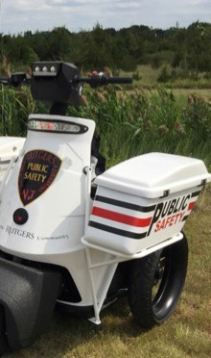

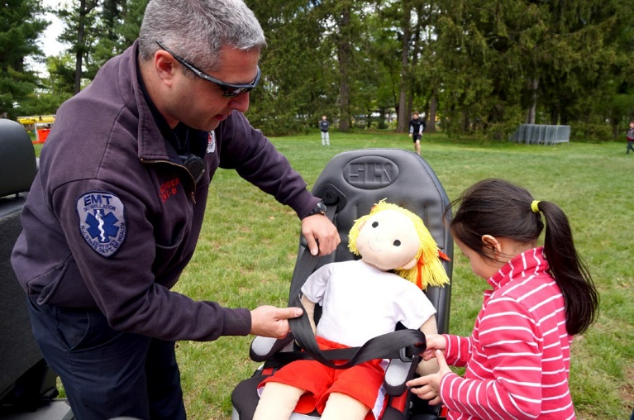
July 1, 2026

TABLE OF CONTENTS

1.0 Service Level Agreement Overview 1

2.0 Description of Services 1

3.0 Service Costs 1

4.0 Service Provider Responsibilities 2

5.0 Problem Management 4

6.0 Key Performance Indicators and Metrics 6

7.0 Periodic Review Process 7

8.0 Out of Scope Services 7

1.0 SERVICE LEVEL AGREEMENT OVERVIEW

This Service Level Agreement (SLA) is intended to identify the basic services, and any agreed upon optional services provided by University Public Safety.

This SLA covers the period from July 1, 2026 - June 30, 2027, and will be reviewed and revised at the end of this period.

2.0 DESCRIPTION OF SERVICES

Public Safety is responsible for responding to all emergencies, suspicious activities, crimes, security and safety concerns. We are committed to providing exceptional police, security, fire safety, medical and emergency management services, 24 hours per day, 7 days per week.
Immediate emergency fire and EMS response can require the assistance of volunteer and or municipal services. Public Safety responds to over 100,000 calls for service annually, ranging in complexity and scale; from community training opportunities to criminal investigations.
Public Safety maintains relationships with our local, state and federal public safety partners in an effort to share information and utilize resources that can assist us in providing safety services.

Please note that public safety emergencies and or disruption to the university’s operations may result in modification of services with limited notice. The services and operations have to be fluid to react to new demand levels imposed by State Executive Orders and CDC guidelines as well impact by the university’s financial standing. As such services and frequencies are adjusted as needed at the discretion of Public Safety.

- SERVICE COSTS

Note: The Public Safety RCM Metric budget allocation is evenly split between space and General and Administrative expenditures.

In developing the fiscal operating budget (Cost Pool), there are numerous assumptions and sensitivities that are addressed. These include but are not limited to:

- Changes in aligned employees collective bargaining agreements
- Fluctuation in fringe benefit rates.
- Rise in contract, equipment and supply costs.
- Unforeseen natural disasters and public safety events.
- Mandated regulatory requirements.

- SERVICE PROVIDER RESPONSIBILITIES

    - Public Safety, through the Rutgers University Police Department (RUPD), shall provide properly trained, equipped and uniformed Rutgers Police Officers, Security Officers and Community Service Officers to perform law enforcement, security services and traffic control on an uninterrupted and continuous twenty-four (24) hour per day, seven (7)
days-per-week basis. This includes: answering calls for service; dispatching public safety personnel to calls for service; follow-up investigations on crimes, incidents and traffic crashes; enforcement of State and University laws and regulations (parking); controlling access to university facilities both physically and electronically; providing a proactive presence via foot and vehicle patrols and generating written reports concerning all incidents or hazardous conditions occurring during each shift of duty. In response to concerns from the community during the global pandemic, the RUPD created an online reporting mechanism “Rutgers Internet Police Reporting System – RIPRS” to facilitate contactless incident reporting of various crimes and offenses for those working remotely and/or concerned with direct interfacing. The RUPD has increased services including the completion of wellbeing checks on-campus and off-campus of students that are suffering from suicidal ideations during the pandemic. The RUPD has also received information about students in crisis and have coordinated with local towns in NJ to complete wellbeing checks on students. The RUPD has received and responded to increased calls for service with regard to homeless populations on and around campus for building access and lock outs and burglar alarms.

    - All 9-1-1 communications, including dispatching, shall be handled by Public Safety only. The 9-1-1 communications center is the regional emergency and non-emergency call center for the Rutgers University system.

    - Public Safety maintains and supports an essential technological infrastructure and information technologies which are needed to facilitate services provided in an efficient and effective manner. Technology includes:
      - Mobile Data Computers
      - Computer Aided Dispatch
      - PowerDMS
      - PowerDetails
      - Field Based Reporting (RMS)
      - Radio System
      - Mobile Video & Audio Recording Cameras (MVAR)
      - Body Worn Cameras (BWC)
      - Alarm Monitoring System (SIS)
      - Tasers
      - Building entry/electronic door access system

    - In compliance with the federal Higher Education Act, Campus Fire Safety Right-to- Know and the Jeanne Clery Disclosure of Campus Security Policy and Campus Crime Statistics Act (20 U.S.C. § 1092(f), University Public Safety publishes a comprehensive annual security report inclusive of information for Camden, Newark, New Brunswick and Piscataway. University Public Safety will continue to collect crime and fire statistics annually for each geographic location of Rutgers, The State University of New Jersey and will publish the following information as required:

      - Three years on/off campus crime statistics
      - Fire log and other related fire safety information
      - Procedures for the reporting of criminal activities and emergencies on campus
      - Policies regarding security of and access to campus facilities
      - Information on law enforcement on campus
      - Emergency response and notification procedures
      - Descriptions of campus security, crime prevention, and alcohol/drug educational programs
      - Policies regarding the possession, use and sale of alcoholic beverages, and illegal drugs
      - Information on campus sexual assault prevention programs and procedures to follow in the event of a sexual assault
      - Procedures on missing student notification
      - Where information concerning registered sex offenders may be obtained

    - The Rutgers Office of Emergency Management (OEM) provides information and communications for planned and unplanned events that may impact public safety. For the greater part of this SLA period and foreseeable future, OEM has provided day-to-day support and guidance during the activation of the Rutgers Emergency Operations Center at all stages (response, recovery, etc.) of incidents that have required the activation of the EOC. In addition, OEM conducts annual reviews of the Emergency Operations Plan (EOP) and submits suggested modifications to the Executive Director of Public Safety. Furthermore, OEM provides basic safety procedures, published in an on-line format, to use in the event of an emergency that threatens public safety. OEM conducts emergency drills on a regular basis and upon request, while working together with municipal and county level counterparts. These procedures are under continual review in order to maintain and enhance the University’s ability to quickly and effectively respond to a public safety emergency.

    - Rutgers University Emergency Services (RUES) is dedicated to enhancing the safety and quality of life for the university community as well as the surrounding areas. RUES provides public safety education, fire prevention, emergency response and emergency medical services. RUES also provides training in CPR/First Aid, Defensive Driving, Fire Safety, etc. and has recently expanded these services to virtual and hybrid models during the pandemic. Emergency Services also provides fire inspections and testing for fire
alarms and fire suppression systems. RUES enhanced ambulance and equipment decontamination procedures and offers this service to departments beyond Public Safety.

      - Public Safety, through the Protection of Minors program, serves as a central resource to provide those interacting with minors the necessary information to protect minors in university sponsored programs and programs hosted by external agencies on university premises.

      - Identity and Access Management provides ID card services as well as a myriad of security technologies services including access control, locksmith services, installation and maintenance of panic and intrusion alarms and cameras. IAM also provides installation and service of door hardware and maintains the university's master keying systems. All technicians are factory trained and certified on all products installed. Since all ID card locations were temporarily closed, Identity and Access Management provided ID card printing services to maintain service levels at all university locations and supported the new student batch printing process for the Fall semester.

5.0 PROBLEM MANAGEMENT

To report an emergency, please dial 9-1-1.

University Public Safety strongly encourages students, faculty, staff, patients and visitors to contact the following representatives for non-emergency inquiries and requests for service.
For matters involving Rutgers University Police Department employees, please visit the Internal Affairs Bureau website at https://ipo.rutgers.edu/publicsafety/internal-affairs.

5.1 SUPPORT & PROBLEM ESCALATION CONTACT LIST

Support Help Line
Name | Role | Phone | Email
Rutgers University Police Department | New Brunswick | 848-932-8407 | rupdcomments@ipo.rutgers.edu
Rutgers University Police Department | Newark | 973-972-4491 OR  973-353-5111 | rupdcomments@ipo.rutgers.edu
Rutgers University Police Department | Camden | 856-225-6111 | rupdcomments@ipo.rutgers.edu
Rutgers University Emergency Services | Emergency Services | 848-932-4800 | es@rutgers.edu
Rutgers Office of Emergency Management | Emergency Management Services | 848-932-4880 | ruoem@ipo.rutgers.edu
Name | Role | Phone | Email
Identity and Access Management | ID Card Services and Security Technologies | 848-445-4956 | iam@ipo.rutgers.edu
Protection of Minors | Steering Committee | 848-932-4914 | protectminors@rutgers.edu
Rutgers University 9-1-1  Shared Services Emergency Communications Center | 9-1-1 Emergency Dispatch Services & General Public Safety Service Requests | Emergency 9-1-1  Non-Emergency 732-932-7211 | publicsafety@ipo.rutgers.edu
Support Contacts
John Bell | Acting Captain Rutgers University Police Department – New Brunswick | 848-932-4881 | John.Bell@rutgers.edu
Carmelo John Huertas | Chief Rutgers University Police Department – Newark | 973-972-7551 | Carmelo.huertas@rutgers.edu
Linne Getsinger | Chief Rutgers University Police Department – Camden | 856-225-2910 | lgets@ipo.rutgers.edu
Brian Emmett Armando Quinones | Acting Captains Rutgers University Police Department -Professional Standards | 848-932-4844 | Brian.emmett@rutgers.edu quinonar@ipo.rutgers.edu
Lauren McLelland | Director Rutgers University 9-1-1 Emergency Communications Center | 848-932-4968 | Lauren.mclelland@rutgers.edu
William Scott | Chief Rutgers University Emergency Services | 848-932-4979 | William.scott@rutgers.edu
Steven Keleman | Director Rutgers Office of Emergency Management | 848-932-4879 | Steven.keleman@rutgers.edu
Name | Role | Phone | Email
Michael Seas | Director Identity and Access Management | 848-445-8180 | Michael.seas@rutgers.edu
Vincent Denota | Director Security Services & Protection of Minors | 848-932-4914 | Vincent.denota@rutgers.edu
Escalation Contacts
Kenneth Cop | Vice President of Public Safety / Chief of University Police | 848-932-4946 | Kenneth.cop@rutgers.edu

- KEY PERFORMANCE INDICATORS AND METRICS

Rutgers University Police Department (RUPD):

    - Policing and security strategies show a reduction or suppression of crime on- and off- campus
    - Compliance with internationally recognized best practices and standards necessary to maintain law enforcement accreditation
    - Management of community perception of policing and security services and maintain favorable approval rating

Communications:

      - 9-1-1 telecommunicators transmit relevant information that allow public safety personnel to effectively respond to calls for service

Technology:

      - Ensure continuous radio communications amongst public safety field personnel and the communications center as well as with key executive level personnel
      - Emergency Notification Systems are available to university constituents and the public

Jeanne Clery Act:

      - Annual security and fire safety report is posted and distributed system wide by the date designated by the Department of Education

Rutgers Office of Emergency Management (OEM):

      - Emergency Action Plans are reviewed annually and made available online to students, faculty, staff and visitors
      - Emergency Operations Plan is reviewed and approved by the Board of Governors
      - Tests of the Emergency Notification System are performed

Rutgers University Emergency Services (RUES):

- Fire inspections are performed in accordance with the NJ Uniform Fire Code
- Evacuation drills are conducted as required by the NJ Uniform Fire Code
- Emergency Medical Services are provided in accordance with NJ Department of Health regulations

Protection of Minors (POM):

- Training regarding safeguards for minors on campus is made available online to program directors, authorized adults and volunteers
- Criminal history and sex offender registry checks are processed in a timely manner

Identity and Access Management (IAM):

- Card readers are maintained and serviced
- ID cards are printed and photos approved
- Access control requests (add, removal, scheduling) are processed in a timely manner

7.0 PERIODIC REVIEW PROCESS

This SLA is a living document and will be reviewed and updated at a minimum of once per fiscal year. Contents of this document may be amended as required, provided mutual agreement is obtained and communicated to all affected parties. Public Safety will incorporate all subsequent revisions and obtain mutual agreements/approvals as required.

- OUT OF SCOPE SERVICES

    - Rutgers University provides 9-1-1 emergency dispatch services for the City of New Brunswick’s police and fire departments, the Borough of Metuchen & Highland Park’s police and volunteer response services and for the Middlesex College Police Department.
    - Rutgers installed and maintained cameras designed to deter criminal activity, aid in criminal investigations and improve safety and security in areas adjacent to campus in off-campus locations in the City of New Brunswick.
    - Special requests by units for installation and maintenance of door access systems, cameras, intrusion and panic alarms.
    - Door and fire watches.
    - Security posts within buildings or specific locations requested by units.
    - Car service.

Billable rates will be based on labor hourly rates plus material. The labor rate will be established each year and subject to change caused by collective bargaining settlements and fringe benefit increases. The service unit will provide an estimate of costs to the requesting unit and the requesting unit will issue an internal purchase order or transfer funds based on the estimate prior to the service unit commencing the work. A final invoice will be issued at the end of the work.

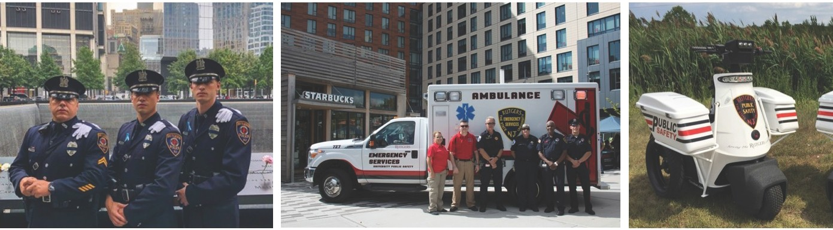

SUPPORTING TODAY, ENVISIONING TOMORROW.

